AIRMAN AND FAMILY READINESS CENTER

KEY SPOUSE PROGRAM



Commander’s Guide

Published by AFPC/DPFFS
26 Sep 2019

Sep 2019 Changes to Key Spouse Program - Commander’s Guide

Page | Change (Add, Delete, Revised)
11 | Added clarifying information on KSP Virtual Initial Training
Appendix K | Revised and added DoD SAFE information
Appendix Q | Added resource information/definitions on: Key Spouse of the Year (KSOY) Award and Volunteer Excellence Award (VEA)
Appendix X | Added information to Commander Checklist on the Key Spouse of the Year Award and Volunteer Excellence Award

Annual Validation (January)

Date | Validation/Program Manager Signature

INTRODUCTION

This Commander’s Key Spouse Desktop Guide has been created to help units manage the Key Spouse Program (KSP). The information in this guide provides guidance and support to get started or to strengthen your existing program. The strategic vision is increase resiliency and unit cohesion among military families throughout the military lifecycle.

This guide is designed to provide a practical approach to develop an effective unit Key Spouse Program. Roles and responsibilities of the Key Spouse Team are defined. The goal is to have a cadre of trained volunteers who can support military families.

The Key Spouse Program is an official Air Force unit family readiness program designed to enhance mission readiness and resilience and establish a sense of community. The Key Spouse Program is a commander’s initiative that promotes partnerships with unit leadership, families, Key Spouses, Key Spouse Mentors, the Airman and Family Readiness Center (A&FRC), and other on and off base helping agencies. We cannot effectively take care of our Airmen and their families without Key Spouses.

Use this guide to update your unit KSP policy and operating procedures to enhance program effectiveness. Air Force Personnel Center, Airman and Family Operations Division serves as the point of contact for questions or concerns. Inquires may be addressed by calling DSN: 665-1366 or Commercial: (210) 565-1366.

MISSION

The mission of the Key Spouse Program (KSP) is to provide information and resources to military spouses, supporting families in successfully navigating throughout the military lifecycle.

VISION

The Air Force family--empowered and resilient.

GUIDANCE

Air Force Instruction (AFI) 36-3009, Airman and Family Readiness Centers, paragraphs
3.9.2 - 3.9.2.7., provides guidance

Table of Contents
INTRODUCTION 2
MISSION 2
VISION 2
GUIDANCE 2
AIR FORCE CHIEF OF STAFF KEY SPOUSE PROGRAM MEMORANDUM 5
HISTORY OF THE PROGRAM 6
Why is the Key Spouse Program Important? 6
Key Spouse Program Outcomes 6
BUILDING THE TEAM: ROLES AND RESPONSIBILITIES 6
Commander (CC) 6
First Sergeant, Chief, Superintendent and/or a SNCO 7
Key Spouse Mentor (KSM) 8
Key Spouse (KS) 8
Airman and Family Readiness Center (A&FRC) 9
KEY SPOUSE PROGRAM LIMITATIONS 10
Fundraising 10
INITIAL TRAINING 11
MENTOR TRAINING 12
TRAINING SUPPORT TO TOTAL AIR FORCE 12
CHILDCARE FOR STANDARDIZED KEY SPOUSE PROGRAM TRAININGS 12
CONTINUING EDUCATION 14
CONSIDERATIONS FOR IMPLEMENTATION OF AN EFFECTIVE KSP 15
Selecting a Key Spouse 15
Steps to Take After Selecting a KS/KSM 15
Motivation and Recognition 15
ESTABLISH A COMMUNICATION PROCESS 16
Diagram 1: Team Communication 17
COMMUNICATION FLOW 17
RE-APPOINTING/REPLACING A KEY SPOUSE OR KEY SPOUSE MENTOR 18
EXCEPTIONS TO THE FOLLOWING CHAIN OF COMMAND 19
SUMMARY 20
APPENDIX A - KEY SPOUSE (KS) POSITION DESCRIPTION 21
APPENDIX B - KEY SPOUSE MENTOR (KSM) POSITION DESCRIPTION 23
APPENDIX C - RECRUITMENT CONSIDERATIONS 25
APPENDIX D - SAMPLE KS/KSM RECRUITMENT E-MAIL 26
APPENDIX E - POSSIBLE KS/KSM INTERVIEW QUESTIONS 27
APPENDIX F - KEY SPOUSE APPOINTMENT LETTER 28
APPENDIX G - KEY SPOUSE MENTOR APPOINTMENT LETTER 29
APPENDIX H - SAMPLE LETTER OF RESIGNATION 30
APPENDIX I - KS/KSM STATEMENT OF UNDERSTANDING 31
APPENDIX J - PERSONALLY IDENTIFIABLE INFORMATION (PII) 32
APPENDIX K - DoD SAFE, AMRDEC and ENCRYPTION TOOL GUIDE 35
APPENDIX L - OPERATIONS SECURITY (OPSEC) 50
APPENDIX M - SUPPORTING FAMILIES DURING DEPLOYMENT 51
APPENDIX N - NATURAL AND MANMADE DISASTERS 54
APPENDIX O - AIR FORCE PERSONNEL ACCOUNTABILITY AND ASSESSMENT SYSTEM (AFPAAS) 55
APPENDIX P - SUICIDE PREVENTION AWARENESS 57
APPENDIX Q - RESOURCES 58
APPENDIX R - MILITARY FAMILY LIFE COUNSELOR (MFLC) PROGRAM 66
APPENDIX S - TIPS FOR OBTAINING A VOLAC 67
APPENDIX T - GUIDELINES FOR KEY SPOUSE OF THE YEAR (KSOY) AWARD 68
APPENDIX U - COMMUNICATION LOG FOR KSs and KSMs 69
APPENDIX V - VOLUNTEER TRACKING LOG FOR KSs and KSMs 70
APPENDIX W - KEY SPOUSE STATEMENT OF CONSENT FOR RELEASE OF PII 71
APPENDIX X - KEY SPOUSE PROGRAM TIPS AND SUCCESS STORIES 72
APPENDIX Y - COMMANDER’S KEY SPOUSE PROGRAM CHECKLIST 78

AIR FORCE CHIEF OF STAFF KEY SPOUSE PROGRAM MEMORANDUM

HISTORY OF THE PROGRAM

The KSP was developed as a quality of life initiative out of concern for Air Force Families. Similar to the Navy’s Ombudsman Program, the AF tested programs at five bases (’96 -’98). Voluntary implementation was encouraged Air Force wide as part of the AF family support outreach program (’99). For many years, the program was installation or command specific. The AF deployed a standardized Key Spouse program in March 2009 with major revisions in 2015.

Why is the Key Spouse Program Important?

  - Promotes individual, family, and unit readiness
  - Establishes continuous contact with spouses/families
  - Encourages peer-to-peer wingman support
  - Provides family links to leadership
  - Strengthen the leadership support team
  - Vital to building strong AF communities

Key Spouse Program Outcomes

- Increases awareness of installation/community resources
- Identifies/resolves issues at lowest levels
- Enhances up/down information flow
- Prepares/supports families during separations
- Increases sense of unit support
- Improves quality of life among unit families
- Increases readiness and retention
- Enhances family resilience

BUILDING THE TEAM: ROLES AND RESPONSIBILITIES

The KSP is a CC program. The CC establishes and maintains the program within the unit, to include choosing team members. The team is typically comprised of the CC, CCF, KSM, KS and A&FRC. CCs may elect to include a Chief, Superintendent and/or a SNCO as members of the KS leadership team.

Commander (CC)

CCs determine and prioritize KS/KSM roles and responsibilities based on unit demographics and needs. Various sample products (see appendix section) are available for commanders to modify as they deem appropriate to support their unit KSP. The CC’s responsibilities include, but are not limited to the following:

- Determines the goals and objectives of Unit KSP
- Recruits volunteer(s) to serve as unit KS
- Sends out a recruitment e-mail
- Interviews KS/KSM candidates to determine if the volunteer is appropriate
representative for the unit
- Officially appoints KS/KSM in writing
- Provides a copy of the signed appointment letter to the Airman & Family
Readiness Center
- Must ensure a Department of Defense (DD) Form 2793, Volunteer Agreement for Appropriated Fund Activities & Non Appropriated Fund Instrumentalities, is completed and maintained on file before a Key Spouse and/or Key Spouse Mentor begins performing duties IAW DoDI 1100.21, Voluntary Services in the Department of Defense. This is a “Tier 0”, non-waiver inspection item.
- Following completion of volunteer service of KS/KSM, as supervisor, signs DD Form 2793, along with obtaining signature of volunteer
- Establishes a KSP file which contains DD Form 2793, KS/KSM appointment letter(s), KS/KSM position description(s), and initial training certificates
- Files KS/KSM resignation letter in the volunteer folder and
- Notifies the A&FRC of KS/KSM resignations as soon as possible
- Schedules a recurring meeting (time/date/frequency) with Unit KS Team to allow the team an opportunity to communicate contacts, needs and/or concerns with unit families, advocate on behalf of unit families, and highlight any trends. This also allows unit leadership the opportunity to ensure the unit KSP is meeting their intent.
- Emphasizes the KSP and KSs during unit tours, CC calls and unit events
- Recognizes the contributions of the KS utilizing the KSP Coin, when warranted and in-line with intent of the KSP Coin, per AFI 36-3009; along with considering the Volunteer Excellence Award and Key Spouse of the Year Award.
- Ensures the KS is provided with unit rosters (need to know information only)
to enable the KS to develop a basic “communication roster” needed to accomplish official volunteer KSP duties
- Determines if the KS/KSM should be granted access to DoD/government computers/networks through the Volunteer Logical Access Credential (VoLAC) Program

First Sergeant, Chief, Superintendent and/or a SNCO

The CCF chief, superintendent and/or a SNCO may monitor the KSP and serve as the CC’s KS primary point of contact for the following:

- Assists the CC in establishing the unit KSP
- Serves as a point of contact for communication with the KS
- Participates in Initial KS Training and Continuing Education via the A&FRC
- Maintains KS/KSM volunteer files, as directed by the Unit CC
- Briefs KS/KSM on what constitutes Personally Identifiable Information (PII),
Privacy Act of 1974 and Operations Security
- Meets with CC, KS and KSM to identify trends and needs
- Offers logistic support (computer, meetings space, KSP/office supplies)
- Provides unit rosters (need to know information only) to enable the KS to develop
a basic “communication roster” needed to accomplish official volunteer KSP
duties
- Assists the CC with recognition of the KS

Key Spouse Mentor (KSM)

The role of the KSM is to serve as an advisor to the KS. This is not a supervisory role but a supportive role. The KSM should be a volunteer who is knowledgeable of the military lifestyle. A KSM is equipped with a high functioning understanding of installation agencies, units, senior AF leadership and spouse networks. A KSM possesses specialized skills of advocacy, influence, community awareness and Air Force connections in line with the Air Force vision. The unit CC may choose whomever he/she deems qualified to perform as a KSM. There is no requirement for a KSM to be the Unit CC’s spouse, nor a requirement for the KSM to have previously served as a Key Spouse.

Duties include:

- Contacts the A&FRC to schedule initial KS training
- Participates in quarterly continuing education/networking opportunities
- Serves as a mentor to the unit KS (share experiences/provide support/encouragement)
- Assists the KS in addressing concerns of unit family members
- Supports KS with family events
- Assists with KS recognition
- Meets with CC and KS Unit Leadership Team regularly, as determined by CC
- Protects sensitive information and unit rosters by using Privacy Act Cover Sheets when in possession of unit rosters/information
- Completes and signs a Department of Defense (DD) Form 2793, Volunteer Agreement for Appropriated Fund Activities & Non Appropriated Fund Instrumentalities, for unit commander to also sign and maintain on file in the unit IAW DoDI 1100.21, Voluntary Services in the Department of Defense
- Submits resignation letter to unit CC when necessary and when preparing to leave volunteer KSM position (Appendix H) and signs DD 2793 at end of volunteer service to the unit

Key Spouse (KS)

The KS contributes to unit readiness by promoting efficient and effective communication between unit leadership, KSM, and unit spouses/families. The KS is a direct link to the CC when establishing and building unit resilience and a sense of community. The unit CC may choose whomever he/she deems qualified to perform as a key spouse. Duties include:

- Contact the A&FRC to schedule initial training
- Meets with CC to establish unit KSP expectations
- Creates KSP implementation strategy according to CC program goals
- Completes mandatory KSP Initial Training
- Completes and signs a Department of Defense (DD) Form 2793, Volunteer Agreement for Appropriated Fund Activities & Non Appropriated Fund Instrumentalities, for unit commander to also sign and maintain on file in the unit IAW DoDI 1100.21, Voluntary Services in the Department of Defense.
- Recruits and encourages new unit spouses to attend Heart Link
- Attends continuing education trainings to remain current on resources and
installation trends
- Obtains basic contact information only on unit families (requires coordination with CC, CCF, Chief, Superintendent and/or a SNCO) to develop a “communication roster” needed to perform KS duties
- Connects with families to verify contact information, clarify preferred method for communication/unit contact and provide information on the unit KSP
- Provides families information on installation and community events
- Provides referral information on base and community resources as needed (Appendix Q)
- Meets with the CC and CCF regularly to discuss needs of unit families
- Protects sensitive information and unit rosters by using Privacy Act Cover Sheets when in physical possession of unit rosters/information
- Submits resignation letter to unit CC when necessary and when preparing to leave volunteer KS position (Appendix H), and signs DD 2793 at end of volunteer service to the unit

Airman and Family Readiness Center (A&FRC)

- Briefs CCs, Command Chief Master Sergeants, and CCFs on the KSP during initial leadership consultation
- Schedules new and reappointed KS/KSM to attend KSP initial, mentor, refresher and continuing education trainings
- Provides Initial Key Spouse Training at least quarterly, or more frequently if needed, using AF standardized key spouse training curriculum. For ARC: initial and annual training is provided as required (IAW AFI 36-3009).
- Should support and provide networking and continuing education/training opportunities to Total Air Force Air Force (Regular Air Force (RegAF), Air Force Reserve Command (AFRC), Air National Guard (ANG), and Air Force Recruiting Services (AFRS)) to compliment initial Key Spouse Training on a quarterly basis, at a minimum, or as requested by installation leadership (IAW AFI 36-3009)
- Provides information to Total Air Force CCs, leadership, KS/KSMs on how to access and complete Virtual Key Spouse Initial Training when classroom/in-seat training is not a viable option
- Provides networking and continuing education/training opportunities for Geographically
Separated Unit (GSU) KSs/KSMs to attend trainings virtually (via Webinar, Skype or
phone)
- Provides training certificate to KS/KSM upon completion of initial trainings
- Provides information and referral resources to KS/KSMs
- Maintains a current roster of all trained KS/KSMs (For Official Use Only)
- A&FRCs must maintain Key Spouse Contact Rosters that contain limited PII (name, home phone number, cell phone number, personal email address) of Key Spouses. A&FRCs may distribute these Key Spouse Rosters to commercial and personal email addresses via unencrypted emails if the Key Spouses whose information is maintained on the roster explicitly consent to this distribution method. Statement of Consent is attached (Appendix W).
  - If a Key Spouse does not consent to having their personal information released to commercial and personal email addresses via unencrypted emails, their personal information will be maintained by the A&FRC on a separate electronic document and will NOT be released.

KEY SPOUSE PROGRAM LIMITATIONS

KSs/KSMs serve in an “official” role as a unit representative and must protect personal information. KS/KSMs are prohibited from sharing Personal Identifying Information (PII) obtained within their official KS duties with other unit spouses. KS/KSMs may not use personal contact information for personal gain. For example, personal contact information obtained on spouses/families cannot be used or shared as a source for potential clients for a business or for a private organization (on or off the installation).

KS/KSMs are not expected to be subject matter experts, nor should they act as counselors. KS/KSMs should utilize referral resources such as the A&FRC, Military One Source, and Military Family Life Counselors (MFLC), as well as other resources on and off the installation as the situation requires.

KSs and KSMs represent the Air Force KSP and serve as unit role model and conduit of accurate information to unit families/military community and when they are asked to step outside of this role, the program can lose credibility and focus. KSs/KSMs should not assume the role of a babysitter, nurse, taxi-driver, social coordinator or fundraiser.

Fundraising

The KSP is not a private organization. It is an official unit readiness program as outlined in AFI-36-3009; thus, as an appropriated fund program, neither KSMs nor KSs are permitted to legally conduct fundraising activities. For example, as a KS/KSM you are not able to participate in fundraising activities through your unit Booster Club; however, as a family member of an active duty unit member you may participate in fundraising activities with the clear understanding you are NOT representing the KSP in any way.

The Force Support Squadron (FSS) Resource Management Office has oversight of private organizations and unofficial activity fundraising.

INITIAL TRAINING

KSP training is thorough, continuous and critical to the KS/KSM in effectively carrying out official duties, which begins with KSP Initial Training. Either prior to or following KSP Initial Training the KS/KSM should also receive an orientation from their KS Unit Leadership Team which will set the foundation for the goals and objectives of the unit’s KSP.

Currently, there are 3 required “standardized trainings” offered within the KSP (Initial Training, Refresher Training and KS Mentor Training). Initial Training can be conducted via in-seat classroom or virtually. KSP Initial Training is facilitated by the installation A&FRC for all newly “officially” appointed KSs and KSMs. Both KSs and KSMs cannot act in an official capacity until the classroom (in-seat) Initial Training or Virtual Initial Training has been completed. The KSP Initial Training (classroom and virtual) consists of eight (8) standardized modules and training time is approximately six (6) hours.

The KSP Virtual Initial Training is not an additional training to the classroom KSP Initial Training, nor is it a supplemental training for the KSP Refresher Training. The KSP Virtual Initial Training is a secondary option being provided to assist KSs/KSMs in meeting out the requirement to complete an AF standardized initial training curriculum. At present time, the classroom KSP Initial Training remains the primary “gold source” method of receiving this required training.

The target audience for KSP Virtual Initial Training is (as of 1 Aug 2019) new officially appointed (via an appointment letter) KSs/KMSs who are located at geographically separated units (GSUs) and those affiliated with the AF Reserve, Air National Guard, and the Air Force Recruiting Services; and especially those who are not co-located on an active duty installation. Additionally, the virtual training is available to KSs/KSMs unable to attend the classroom training because they are full-time professionals, Family Day Care Providers and those who home-school their children.

KSs/KSMs must coordinate with both their Commander and the A&FRC before they initiate the KSP Virtual Initial Training, so it can be determined if the virtual training is the best training method for them; and to obtain the step-by-step instructions from the A&FRC on how to access KSP Virtual Initial Training. Prior to taking the virtual training an “official” appointment letter must be on file with the A&FRC and in the KS’s/KSM’s unit.

MODULES

- KS Overview
- Communication
- Generational Diversity
- Social Media, Operations and Cyber Security
- Deployment
- Disaster Preparedness
- Information Security
- Resilience

Module 8, will be facilitated by the installation’s Community Support Coordinator (CSC) or a designated Master Resilience Trainer (MRT) selected by the installation CSC. Unless being conducted via the virtual training.

In addition to the eight (8) standardized modules, a one-time attendance of Heart Link is recommended for all KSs and KSMs to gain an understanding of the important role they play in recruiting and encouraging new Air Force spouses to attend Heart Link.

MENTOR TRAINING

Developed in April 2018 as one of the three “standardized” KSP trainings. Mentor Training can vary from 1-2 hours in length, depending upon class size and interaction during customized scenarios. Mentor Training is a one-time mandatory training for all new KSMs and is intended to be taken after Initial Key Spouse Training.

TRAINING SUPPORT TO TOTAL AIR FORCE

A&FRCs on main operating bases (MOBs) will support Total Air Force, which includes GSUs, Air Force Reserve, Air National Guard and Air Force Recruiting Service KSs and KSMs. Organizations must coordinate in advance with a MOB to:

- Obtain information on Virtual Key Spouse Initial Training or initial classroom training if TDY funding is available
- Arrange for customized training for the GSU KSs/KSMs
- Join/attend an existing scheduled classroom Key Spouse Training being conducted by the MOB via Skype or phone.

KS/KSMs are not required to re-accomplish initial training following a Permanent Change in Station (PCS). A one-hour standardized recurring refresher training (along with local trend and resource information) for both the KS and KSM must be accomplished at the new local A&FRC prior to functioning as a KS/KSM at the new duty location. As a reminder, when PCSing to a new assignment KS/KSM should travel with their KS certificate(s) of completion to show proof of initial KSP training to the inbound A&FRC.

CHILDCARE FOR STANDARDIZED KEY SPOUSE PROGRAM TRAININGS

The Air Force Aid Society (AFAS) provides up to 12 hours of childcare, per child, in an Air Force certified Family Child Care home. Funding is via the AFAS “Child Care for Volunteers Program”, using the following AFAS eligibility criteria: Spouses of active duty AF members to include Air National Guard and Reserve members activated under Title 10, USC for more than 15 days, engaged in volunteer activities that support base programs which benefit the Air Force community.

AFAS funded childcare may be used for the following KSP trainings: Initial Training (6 hours, one-time training for KSs and KSMs), Key Spouse Mentor Training (1 hour, one-time training for KSMs only) and Refresher Training (1-hour, recurring training only upon PCSing, should a KS or KSM decide to resume official duties via appointment letter by a unit commander). AFAS funded childcare may NOT be used for Virtual Key Spouse Initial Training.

CONTINUING EDUCATION

Installation A&FRCs should provide networking / education opportunities to compliment Initial Key Spouse Training on a quarterly basis, at a minimum, or as requested by installation leadership IAW AFI 36-3009. These are continuing education opportunities for both KSs and KSMs. Continuing education topics are NOT limited to the topics below as installations may have unique needs based on their geographical location and mission. Continuing education trainings may be facilitated via traditional classroom/in-person training, as well as by using different types of platforms such as computer-based trainings (CBT), webinars, Skype, video, Podcasts, and via online Military OneSource Trainings.

Annual Requirements:

- Suicide Awareness

The KS should keep crisis phone numbers near their telephone
- Sexual Assault Prevention and Response (SAPR)

Suggested Continuing Education Topics:

- Heart Link
- AFRC and ANG 101 (where applicable)
- True Colors or Four Lenses, personality assessments
- Deployment Readiness
- Crisis and Disaster Response/Preparedness (with interactive scenarios)
- Evacuation Operations (with interactive scenarios)
- Air Force Personal Accountability and Assessment System (AFPAAS)
- Social Media
- Presentations by local companies/employers who hire military spouses
- Additional resilience training
- American Red Cross
- Cybersecurity
- Military OneSource Trainings/Podcasts (MFLC Program, Relationship Health, Family Wellness, TRICARE, Money Management, Spouse Education, and many more)
- Toastmasters (public speaking, communication and leadership Skills)
- Parliamentarian procedures/how to conduct a meeting/Robert’s Rules for meetings
- Installation Agencies/Programs: Force Support Squadron/Flights; Legal Office; Public Affairs; A&FRC Programs (EFMP, TAP, PFR, RELO, Gold Star Families, etc.), Family Advocacy Office; New Parents Support; Alcohol and Drug Abuse Prevention and Treatment (ADAPT); Mental Health; Education Office; and Universities/Colleges.
- Local community agencies: Social Services; Employment Office; Food Banks; Women, Infants, and Children (WIC); Community Colleges/Universities, Chamber of Commerce; community center; police; and county sheriff.

CONSIDERATIONS FOR IMPLEMENTATION OF AN EFFECTIVE KSP

Selecting a Key Spouse

Ideal KS/KSM characteristics include:

- Positive attitude about the Air Force
- Ability to communicate and listen
- Passion, time and energy to do the job
- Organizational skills and attention to detail
- Ability to follow directions
- Trustworthy/discreet/reliable/loyal
- Dependability
- Outgoing, friendly and self-confident

Steps to Take After Selecting a KS/KSM

- Sign and send appointment letter to A&FRC (Appendix D)
- Refer KS/KSM to A&FRC to schedule Initial Training or one-hour Refresher Training (for KS/KSMs trained after 2015)
- Meet with KS/KSM to communicate expectations regarding vision for unit KSP and to discuss and clarify roles of unit KS Team
- Introduce KS/KSM to the unit
- Invite KSs/KSMs to CC calls, unit newcomer briefings, promotion ceremonies and other appropriate unit functions

Motivation and Recognition

A highly motivated KS will provide extensive outreach to unit families. Below are some tips for recognizing and motivating KSs and KSMs:

- Express sincere, personal thanks for efforts and contributions
- Introduce KSs/KSMs during incoming briefings and unit, wing and community functions
- Respect opinions and suggestions
- Public hail and farewell for KSs/KSMs
- Consider presentation of a unit coin when deemed appropriate by CC
- Consider Volunteer Excellence Award (VEA) submission (contact installation A&FRC)
- Consider nomination for the annual Air Force Key Spouse of the Year (KSOY) award (Nov/Dec timeframe) – See Appendix R

ESTABLISH A COMMUNICATION PROCESS

Communication is the key to program success. The CC, in concert with the Unit KS Leadership Team, will establish expectations for communication to unit leadership and the unit families. Communication considerations include:

- Meeting frequency (suggest at least quarterly)
- Unit communication plan/expectations
- Information flow, up/down chain
- Crisis/disaster communication plan
- Family notification procedures
- Logistical support required (typically KS works from home)
- Meeting space
- Use of telephone/computer if needed/required
- Grounds/procedures for dismissal or replacing KS volunteer(s)

Diagram 1: Team Communication

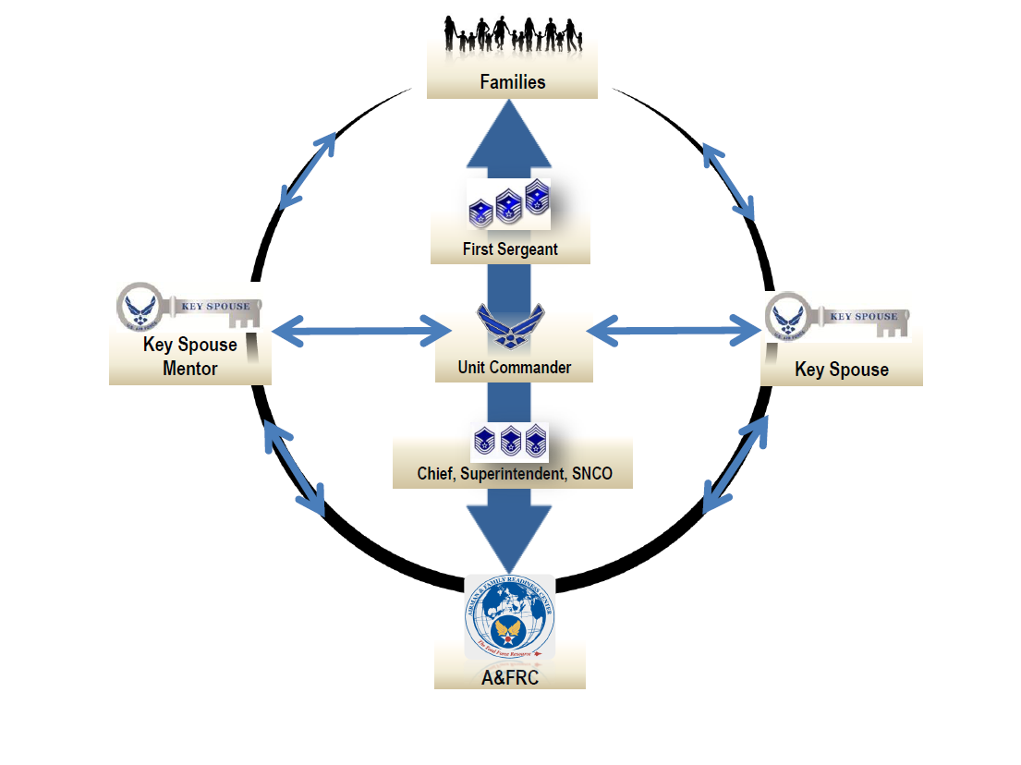

COMMUNICATION FLOW

The success of the KSP is dependent upon the concise flow of information. Quarterly meetings are recommended to establish expectations and monitor unit needs.

The flow of information is reciprocal between leadership and the KS. The KS, in turn, provides information to unit spouses via email, text, phone, newsletters, meetings, social media and other applicable forms of communication. The KS should take note of recurring requests or needs from unit spouses and relay trends or concerns back to unit leadership.

Additionally, to enhance communication across the installation, it is recommended unit KS teams meet regularly to share information.

RE-APPOINTING/REPLACING A KEY SPOUSE OR KEY SPOUSE MENTOR

New Unit CCs may re-appoint, in writing, trained KSs/KSMs and/or appoint new KSs/KSMs upon assumption of command. Consider replacing KSs/KSMs when:

- Performance is unsatisfactory
- Confidentiality, PII, Privacy Act, and/or Operations Security is breached
- Unable to follow through on assigned tasks
- Unwilling to participate in unit-specific events
- Loss of confidence and trust
- Poor match with unit KSP vision and expectations
- Burnout

All KS/KSM selections/appointments/firings should be documented and communicated in person.

EXCEPTIONS TO THE FOLLOWING CHAIN OF COMMAND

Both KSs and KSMs have been provided with the following guidance.

- Suicidal Ideation (thinking about or planning suicide) – Call 911 immediately and stay with the individual until help arrives. (Appendix H). Notify the unit CC after help is sought.

- Child Abuse/Neglect – If emergent call 911. If the victim is not at risk of imminent harm, contact your installation Family Advocacy Program (FAP) to report concerns. KSs/KSMs are not mandatory reporters of child abuse/neglect; however, in their trusted positions they should report all suspicions of child abuse/neglect to FAP and Unit CC.

- Sexual Assault – The KS/KSM should refer a victim of sexual assault to the installation Sexual Assault Response Coordinator (SARC) or a Victim Advocate (VA), via the installation Sexual Assault Prevention and Response (SAPR) office. Should the situation necessitate a warm hand-off of the victim to additional support agencies, the SARC or VA will ensure this occurs. The installation SARC or VA can also provide information on
Reporting options (*Unrestricted/**Restricted). Assistance is available 24/7 via the SEXUAL ASSAULT HELPLINE number (877-995-5247) and website at: www.safehelpline.org (Appendix G).

The KS/KSM should not report a sexual assault directly to the unit leadership team as they are mandated reporters and doing so may remove the victim’s option to file a **restricted report.

- ***Partner/Spouse Abuse – If emergent call 911. If the victim is not at risk of imminent harm, in order to preserve an adult victim's right to the **restricted reporting option for domestic abuse; KS/KSM should strongly encourage the victim to speak to a domestic abuse victim advocate (DAVA), a FAP provider, medical provider, or a Military OneSource (MOS) provider.

***Medical providers (including MOS) are required to refer the victim to FAP and the option for a **restricted report is preserved.

***“Direct reporting” of domestic abuse to law enforcement, commanders, unit leadership team or FAP by the KS/KSM could jeopardize the victim's **restricted reporting” option.

*Unrestricted Reporting: Allows a sexual assault victim to disclose the details of his or her assault and receive medical treatment and counseling; Law enforcement will be notified. Unrestricted reporting is the same reporting option for any other crime reported in the military. The commander and first sergeant are notified to ensure the well-being of the service member and of a probable investigation. The SAPR office is still involved and provides all services requested. These services will continue through any legal processes.

**Restricted Reporting: Allows a sexual assault victim to confidentially disclose the details of his or her assault and receive medical treatment and counseling; no investigation is initiated and the victim's command is not notified. A restricted report is between the survivor and the SARC, and all of the services offered by the SAPR Office are available.

***Statements above regarding Partner/Spouse Abuse have been provided by the Air Force Medical Operations Agency (AFMOA) and are in line with the KS and KSM volunteer roles.

SUMMARY

The KSP enhances mission and personal readiness by providing an avenue for two-way communication between unit leadership and families. The KSP has demonstrated success in strengthening units while building a sense of belonging and community.

APPENDIX A - KEY SPOUSE (KS) POSITION DESCRIPTION

The KS is a volunteer selected and appointed in writing by the Unit Commander (CC) to act as an official unit readiness representative. The KS serves as a trusted agent between unit leadership and families. The KS works with unit leadership and the Key Spouse Mentor (KSM) to plan, coordinate, and execute the unit KS program through two-way communication and community information and referral.

The KS serves as the focal point for communication with spouses/families and actively markets the program through visibility at unit commander’s calls, unit or base events, and by deliberate communication through phone, e-mail or social networks. Through leadership and community connections, the KS effectively communicates unit information and community resources to families. The KS is an advocate for families.

Through two-way communication and a direct connection to unit leadership via deliberate and regular meetings and interactions, the KS (alongside the KSM) advocates for unit needs and concerns, and assists the commander in identifying unit strengths and challenges. All KSs/KSMs are volunteers and accountable to the CC (or designee), not another KS/KSM; thus both have equal status regardless of their experience level or time of service and one is not to be appointed as lead or supervisor over another.

In an official capacity, the KS collaborates with unit leadership to build or maintain a unit communication roster with basic family contact information needed to communicate with unit families. KS volunteers are, IAW 10 USC 1588, required to comply with the Privacy Act of 1974 (see 10 USC 1588(d) (C)), and as such, providing KSs with access to Privacy Act Information is not a prohibited disclosure as long as the disclosure is in connection with the performance of official duties as a Key Spouse; and information is protected by utilizing the Privacy Act of 1974 cover sheet.

KEY SPOUSE DUTIES AND RESPONSIBILITIES:

- Provides peer-to-peer support to unit families
- Serves as communication link between unit leadership and families
- Offers information/referral to families on community agencies and resources
- Recruits and encourages new Air Force spouses to attend Heart Link
- Protects Personally Identifiable Information (PII) and complies IAW 10 USC 1588, with the
Privacy Act of 1974 (see 10 USC 1588(d) (C))
- Will use Privacy Act of 1974 Cover Sheet
- Welcomes new families to the unit and cultivates relationships within the unit
- Actively participates in unit and installation functions
- Track volunteer hours and information disseminated
- Submit resignation to unit CC when necessary (Appendix F)

Desired Qualities: Effective oral and written communication skills; ability to adhere to privacy and confidentiality guidelines; willingness and ability to complete required training; a positive outlook on the military lifestyle; willingness to support new and experienced military spouses; is empathetic and caring and has keen organizational skills and attention to detail.

Required Training:

- One-time completion of KSP standardized Initial Classroom Training (8 Modules, 6 hours) or Virtual Initial Training, if applicable
- Standardized Refresher Training (1-hour, required recurring training only upon PCSing), developed for KSs and KSMs returning to official KS/KSM duties (signed appointment letter by a unit commander) following a PCS to a new duty location
- To remain current on community programs/resources for families, it is highly
recommended that KSs participate in quarterly continuing education opportunities
provided by the A&FRC.
- Annual Suicide Awareness Training
- Annual Sexual Assault Prevention and Response (SAPR) Training

APPENDIX B - KEY SPOUSE MENTOR (KSM) POSITION DESCRIPTION

The KSM is a volunteer, selected and appointed in writing by the unit (CC) to act as an official unit readiness representative. The unit CC may choose whomever he/she deems qualified to perform as a KSM. There is no requirement for a KSM to be the unit CC’s spouse, nor a requirement for the KSM to have previously served as a Key Spouse (KS). The KSM serves as a trusted agent between unit leadership, its members and families. The KSM works with the Unit Leadership Team to plan, coordinate, and execute the unit Key Spouse Program (KSP).

A KSM is an effective representative and a knowledgeable role model for the KS Leadership Team and unit families. It is the KSM’s years of personal first-hand experience of the military lifestyle and specialized skills of advocacy, influence, community awareness, Air Force connections, along with the Air Force’s vision and priorities that make KSM volunteers ideal for this position.

Through two-way communication and a direct connection to unit leadership via deliberate and regular meetings and interactions, the KSM (alongside the KS) advocates for unit needs and concerns, and assists the CC in identifying unit strengths and challenges. All KSs/KSMs are volunteers and accountable to the CC (or designee), not another KS/KSM; thus both have equal status regardless of their experience level or time of service and one is not to be appointed as lead or supervisor over another.

KSM volunteers are, IAW 10 USC 1588, required to comply with the Privacy Act of 1974 (see 10 USC 1588(d) (C)), and as such, providing KSMs with access to Privacy Act Information is not a prohibited disclosure as long as the disclosure is in connection with the performance of official duties as a KSM; and information is protected by utilizing the Privacy Act of 1974 Cover Sheet (Appendix Q).

KEY SPOUSE MENTOR DUTIES AND RESPONSIBILITIES:
  - Mentor the unit KS(s) (share experiences, advise, provide support/encouragement).
  - Actively participate in unit and installation functions.
  - Offer information/referral to families on community agencies and resources.
  - Protect personal identifying information (PII) and will comply, IAW 10 USC 1588, with the Privacy Act of 1974 (see 10 USC 1588(d) (C)); will use Privacy Act Cover Sheet (Appendix Q).
  - Help unit leadership recognize and show appreciation to unit KS(s).
  - Recruits and encourages new Air Force spouses to attend Heart Link.
  - Track volunteer hours and information disseminated.
  - Submit resignation to unit CC when necessary (Appendix J).

Desired Qualities: Exceptional oral and written communication skills; ability to plan and organize; has a high functioning knowledge of installation agencies, units, senior AF leadership and spouse networks, or can quickly establish a knowledge of; ability to work cooperatively with unit KS(s), Unit Leadership Team and installation KS/KSMs; can adhere to privacy and confidentiality guidelines; has ability to avoid conflict of interest; a positive outlook on the military lifestyle; ability and willingness to complete required training; possesses strong self-awareness; prepared to support new and experienced military spouses.
Required Training:

- One-time completion of standardized KSP Initial Classroom Training (8 Modules, 6 hours), or Virtual Initial Training, if applicable
- One-time completion of standardized KSP Mentor Training (1 hour)
- Standardized Refresher Training (1-hour, required recurring training only upon PCSing), developed for KSs and KSMs returning to official KS/KSM duties (signed appointment letter by a unit commander) following a PCS to a new duty location
- To remain current on community programs/resources for families, it is highly recommended that KSMs participate in quarterly continuing education opportunities provided by the A&FRC
- Annual Suicide Awareness Training
- Annual Sexual Assault Prevention and Response (SAPR) Training

APPENDIX C - RECRUITMENT CONSIDERATIONS

Recruitment of KSs/KSMs is critical to the KSP. CCs should consider turnover and training time in their recruitment plan. Below are some considerations for recruitment.

Assessing unit needs

How many KSs/KSMs do you need for your unit?
Does the current number of KSs/KSMs meet your unit needs?
How long has your KS/KSM been volunteering in this capacity?
Do your KS/KSM applicants have full-time jobs?
How much time do you expect your KS/KSM volunteer to provide?
Does your current KS/KSM have recommendations?
Does your CCF have recommendations of spouses for the KS/KSM position(s)?
Is the current KS/KSM experienced?
Do you want the KS to be actively involved in welcoming unit newcomers?
How much does your unit know about the KSP?
How involved are unit spouses/families in unit events?
How supportive are unit members of their spouses/families getting more involved in the unit?
Do you have a need for a KSM?
Do you have any spouses who are operating as KSs/KSMs without a proper appointment letter or having received official training?

Marketing

What is the best way to market your KSP?
Do you have a method to get information to spouses/family members?
Do your military members take information home to share with spouses/family members?
How will your unit identify the KS?
How will the unit learn about the KSP?
Are you providing office supply items for your KS/KSM to perform their duties?
Does your unit have/use social media or some other method to get information to families?

Turnover

Do you know when your current KS/KSM is scheduled to PCS?
Can you build in overlap time to train new KS/KSM volunteer(s)?

Assessing Applicants

Do you prefer to have a resume from applicants?
Will you ask for personal references?
Have you considered what you will tell candidates who were not selected?
Have you considered how you will engage or involve non-selected candidates in unit activities?

APPENDIX D - SAMPLE KS/KSM RECRUITMENT E-MAIL

XXX Unit Spouses,

I am committed to supporting our unit families and want to ensure you are aware of an important unit program. The Key Spouse Program (KSP) is a vital link to connect our families to information and resources.
I am actively looking for qualified volunteers to join our Unit Key Spouse Team. KSs/KSMs receive free KSP Training through the Airman & Family Readiness Center (A&FRC). Continuing education training is also conducted to help keep skills and knowledge current. I am looking for motivated and energized volunteers who would like to join me in building a stronger AF community by supporting our unit families. Interested volunteers should contact myself or _______________ to discuss the duties and additional information about the position.

Sincerely,

APPENDIX E - POSSIBLE KS/KSM INTERVIEW QUESTIONS

The CC interview of KS/KSM applicants is an opportunity for the CC to ask questions to determine the potential of each candidate to serve as a KS. The list of questions below is meant to provide you with a starting point and is not all-inclusive.

Getting to know the applicant

Tell me about yourself.
What do you consider your best strength?
In what type of environment do you work best?
What is one area you are currently working to improve?
How would you describe your personality?
How would your friends describe you?
What is your most cherished AF experience?
What do you consider your worst AF experience? And, what did you learn about yourself afterwards?

Assessing Knowledge, Skills and Abilities

What do you know about the KSP?
What skills do you believe you would bring to the KSP?
Describe your experience working with military spouses and/or families.
Describe how you think a KS/KSM should build trust with unit spouses.
Describe what a well-functioning KSP team looks like.

Assessing Commitment

Why do you want to be a KS/KSM?
How much time do you think the KS/KSM position requires?
Why are you interested in becoming a KS/KSM?
Are you available to attend all the required KSP trainings?

Assessing the applicant’s views on the Key Spouse Program

What do you think our unit spouses need from a KS/KSM?
What do you think is the most valuable aspect of the KSP?
What do you believe is the role of the KS/KSM?
What resources do you feel a KS/KSM needs to be successful?

APPENDIX F - KEY SPOUSE APPOINTMENT LETTER

Organizational Letterhead

MEMORANDUM FOR (Name of Key Spouse)
FROM: (___/CC) Rank and Name
SUBJECT: Key Spouse (KS) Appointment

- You have been appointed as Key Spouse for the (name of the unit).
- As a Key Spouse representing our unit, you will be required to:

- Complete eight (8) modules of Key Spouse Initial Training (approximately 6 hours), or Virtual Initial Training, if applicable
- If previously completed required Initial Training, then complete standardized Refresher
Training (1 hour), designed for KSs and KSMs returning to official KS/KSM duties
following a PCS to a new duty location
- Attend continuing education opportunities to remain current on local resources and
trends both on and off the installation, and relevant to the KSP
- Complete Annual Training on Suicide Awareness and Sexual Assault Prevention and Response (SAPR)

All trainings are provided by the Airman and Family Readiness Center (A&FRC).

(Commander’s signature block)

1st Ind,

I, _________________________, accept appointment as (name of unit) KS volunteer. The above named Key Spouse agrees to protect personally identifiable information (PII), adhere to the Privacy Act of 1974 and exercise Operations Security.

________________________ _______________
Key Spouse Signature Date

Cc: CCF/Chief/Superintendent

The above named KS completed Initial Key Spouse Training or Refresher Training.

__________________________ ________________
A&FRC Staff Signature Date

APPENDIX G - KEY SPOUSE MENTOR APPOINTMENT LETTER

Organizational Letterhead

MEMORANDUM FOR (Name of Key Spouse Mentor)
FROM: (___/CC) Rank and Name
SUBJECT: Key Spouse Mentor (KSM) Appointment

- You have been appointed as a Key Spouse Mentor for the (name of the unit).

- As a Key Spouse Mentor representing our unit, you will be required to:

  - Complete eight (8) modules of the KSP Initial Training (approximately 6 hours), or
Virtual Initial Training, if applicable
  - If previously completed required Initial Training, then complete standardized Refresher
Training (1 hour), designed for KSs and KSMs returning to official KS/KSM duties following a PCS to a new duty location
  - Complete Mentor Training (1 hour), effective April 2018
  - Complete Annual Training on Suicide Awareness and Sexual Assault Prevention and
Response (SAPR)
  - Also, to remain current on local resources and trends both on and off the installation, the A&FRC provides opportunities for KSMs to attend continuing education on various topics relevant to the KSP

(Commander’s signature block)

1st Ind,

I, _________________________, accept appointment as (name of unit) KSM volunteer. The above named Key Spouse Mentor agrees to protect personally identifiable information (PII), adhere to the Privacy Act of 1974 and exercise Operations Security.

________________________ _______________
Key Spouse Mentor Signature Date

Cc: CCF/Chief/Superintendent

The above named KSM completed Initial KS, KSM and/or Refresher Training

__________________________ ________________
A&FRC Staff Signature Date

APPENDIX H - SAMPLE LETTER OF RESIGNATION

DD MMM YY

MEMORANDUM FOR [Insert unit CC name]

FROM: [Insert KS/KSM Name]

SUBJECT: Key Spouse / Key Spouse Mentor Resignation Letter

1. I hereby resign my appointment as the KS/KSM for (insert unit name), effective (DDMMYY).

2. Please accept my heartfelt thanks for the opportunity to volunteer in this capacity and serve the men, women and families of the (insert unit name).

[KS/KSM signature block]

APPENDIX I - KS/KSM STATEMENT OF UNDERSTANDING

The purpose of this document is to serve as an agenda for the initial meeting between the CC, KSM, KS, CCF, Chief, Superintendent and/or SNCO to certify that the KS/KSM understands and agrees on the guidelines and parameters of the program.

- Discuss the unit mission and how it folds into the installation mission.

- What are the CC/CCF/Chief/Superintendent/SNCO expectations/priorities for the KSP?

- What is the role of the CCF, Chief, Superintendent or SNCO in the KSP?

- Who are the POCs that the KS/KSM should call upon for information and support?

- How often are rosters updated? How will KSs know if new families arrive?

- What are the CC’s expectations for a crisis response plan?

- What types of situations does the CC want reported to him/her?

- What administrative support is available?

- Will the CC give the KS/KSM a tour of the unit with introductions to key service
members?

- How will the unit fund the program as needed for supplies and family activities?

I, ______________________________understand and agree to the guidelines and parameters discussed in this document and promise to abide by them.

________________________________________ ___________________
Key Spouse / Key Spouse Mentor Signature Date

________________________________________ ___________________
CC Signature Date

APPENDIX J - PERSONALLY IDENTIFIABLE INFORMATION (PII)

Information contained within Appendix J was created and provided by Air Force Personnel Center/Freedom of Information Act/Privacy Act, (FOIA/PA) Office (AFPC/DSMEF) and reviewed by AFPC/JA to insure current and accurate information on PII and Privacy Act of 1974 has been provided to Key Spouses and Key Spouse Mentors for a clear understanding and responsibility to adhere to these programs within.

It is everyone's duty and obligation to ensure PII is properly collected, accessed, used, shared and disposed of within the Air Force (AF) workplace at all times. PII is defined as any information about an individual maintained by an agency that can be used to distinguish or trace an individual's identity, such as their name, social security number, date and place of birth, mother's maiden name, biometric records, etc.

Protecting PII is a responsibility of every active duty AF member, DoD civilian, DoD contractor and volunteers. Loss of PII poses a risk to personnel as well as the security of our installations and systems.

In order to safeguard PII, sending PII to a personal e-mail account is strictly prohibited. All e-mails containing PII or other sensitive information must be encrypted, unless the owner of the PII explicitly consents to its distribution via unencrypted means.

A&FRCs must maintain Key Spouse Rosters that contain limited PII (name, home phone number, cell phone number, personal email address) of Key Spouses. A&FRCs may distribute these Key Spouse Rosters to commercial and personal email addresses via unencrypted emails if the Key Spouses whose information is maintained on the roster explicitly consent to this distribution method. A sample Statement of Consent is attached at Appendix X.

DoD 5400.11-R, DoD Privacy Program and AFI 33-332, Air Force Privacy and Civil Liberties Program establish requirements for safeguarding PII.

The majority of the privacy breaches result from persons emailing (or transporting) official files that contain PII. The predominant number of breaches resulted from emailing "alpha-type" rosters often times with ranks, social security numbers, and organizations from our .mil to a .com network (e.g., Gmail). AFI 33-332 prohibits emailing or transferring any PII from .mil to .com networks. This will further restrict the use of the PII we collect on our Airmen to the official DoD or Air Force systems that support managing the force (e.g., finance, training, readiness, etc.).
Requirements to remotely, electronically access this type of information must rely on AF-provided virtual private networks or similar secure services.

Alternate means are available to transmit PII or other sensitive information when email encryption is not possible.

These include the following:
  - Regular mail
  - Hand delivery
  - DoD-approved file exchange capability, such as the Safe Access File Exchange, which can be found at the following website: https://safe.amrdec.army.mil/safe/Welcome.aspx., or in Appendix K

When Transmitting PII via e-mail:
  - Emails containing PII information, which require a FOUO protective marking, can only be sent using a CAC (Common Access Card) enabled e-mail account to another CAC- enabled/protected email account. Thus, FOUO information CANNOT be sent to KSS/KSMs g-mail, Hotmail, accounts.
    - The only exception to this rule is if the owner of the PII explicitly consents to the distribution of their PII to commercial or personal email addresses via unencrypted emails. A sample Statement of Consent is attached at Appendix V.
  - Ensure recipient(s) have official need to know
  - Digitally sign & encrypt
  - Place “FOUO” at beginning of “subject line”
  - Begin emails with:
“This e-mail contains FOR OFFICIAL USE ONLY (FOUO) information which must be protected under the Freedom of Information Act (5 U.S.C 552) and/or the Privacy Act of 1974 (5 U.S.C. 552a). Unauthorized disclosure or misuse of this PERSONAL INFORMATION may result in disciplinary action, criminal and/or civil penalties. Further distribution is prohibited without the approval of the author of this message unless the recipient has a need to know in the performance of official duties. If you have received this message in error, please notify the sender and delete all copies of this message.”

DO NOT place above FOUO statement within “signature blocks”

DO NOT indiscriminately apply FOUO statements to emails:
  - Use only when transmitting PII

DO NOT send unencrypted emails containing PII to distribution or group e-mail addresses

Individuals requiring access to PII via a government issued computer in order to accomplish their official duties from home or TDY should contact their local Information Management Office or Local Communications Squadron.

Information that Requires Protection (do not release outside DoD without written consent from each individual). Written consents must be maintained for 6 years.

  - Lists of names (two names, line and blocks charts, directories, rosters, etc., are a list)
  - Marital status (single, divorced, widowed, separated)
  - Number, name, existence and sex of family members
  - Civilian educational degrees and major areas of study (unless positive educational requirement for employment)
  - School and year of graduation
  - Home of record (city and state MAY be releasable, street address no)
  - Home address and phone (includes individually assigned home & work email addresses, and cell, home & work numbers)
  - Age and date of birth (year)
  - Present or future assignments for overseas or for routinely deployable or sensitive units (RDU)
  - Office and unit address and duty phone for overseas or for RDU units, all persons below O-7 rank
  - Race/ethnic origin, religion
  - Educational level (unless positive educational requirement for employment)
  - Social Security Number and/or DoD Identification Number

APPENDIX K - DoD SAFE, AMRDEC and ENCRYPTION TOOL GUIDE

There are a couple of options available when exchanging (sending) large unclassified files that cannot be sent through email and that also meets encryption/protection requirements for FOUO/PII.

- As of September 2019, the DoD SAFE website, https://safe.apps.mil/ is active and ready for use to exchange unclassified files up to 8.0 GB. Following a review by SAF/A6, DoD SAFE has been approved and deemed secure to utilize when sending sensitive information (PII, PHI, FOUO, CUI). Also, options A & B below are available for additional security.

- Encrypt the document first using DoD Encryption Wizard then upload it to DoD SAFE. Send the password to the recipient in a separate email.

* Encryption Wizard can be download for both DoD and non-DoD users at https://www.spi.dod.mil/docs/EncryptionWizard-Unified-3.5.3-FIPS.zip

OR

- Password protect the document before uploading it to DoD SAFE. Send the password in a separate email to the recipient.

- AMRDEC (pronounced: am – err – deck) as a standalone service not approved by SAF/A6 Compliance and Policy Officer. However, the Encryption Tool has been authorized by AF/A6 Compliance and Policy Officer to use in conjunction with AMRDEC when sending For Official Use Only (FOUO) and Privacy Identifiable Information (PII). As a reminder, use encryption email when sending small size documents. Guidance on how to use the Encryption Tool is provided below.

A. Use of DoD Encryption Wizard

1. Encrypt large documents before transmitting via AMRDEC
2. AMRDEC Link: https://safe.amrdec.army.mil/safe/
3. Additional guidance is found on the AF Portal: https://www.my.af.mil/gcss-af/USAF/ep/contentView.do?contentType=EDITORIAL&contentId=c41A685A467113F54016712E2D5AA0014&programId=t2D8EB9D643DF9257014403111F5D022C&channelPageId=s6925EC1356510FB5E044080020E329A9
4. Encryption Wizard is available in Government and Public (external government customers) Editions

B. How to Use the Government Encryption Wizard Edition

1. Download Encryption Wizard zip file from DoD Trusted End Node Site: https://www.spi.dod.mil/download.htm#ew

2. Under Encryption Wizard, version 3.5.3, released date 26 Sep 2018; select the Encryption Wizard, Government Edition”

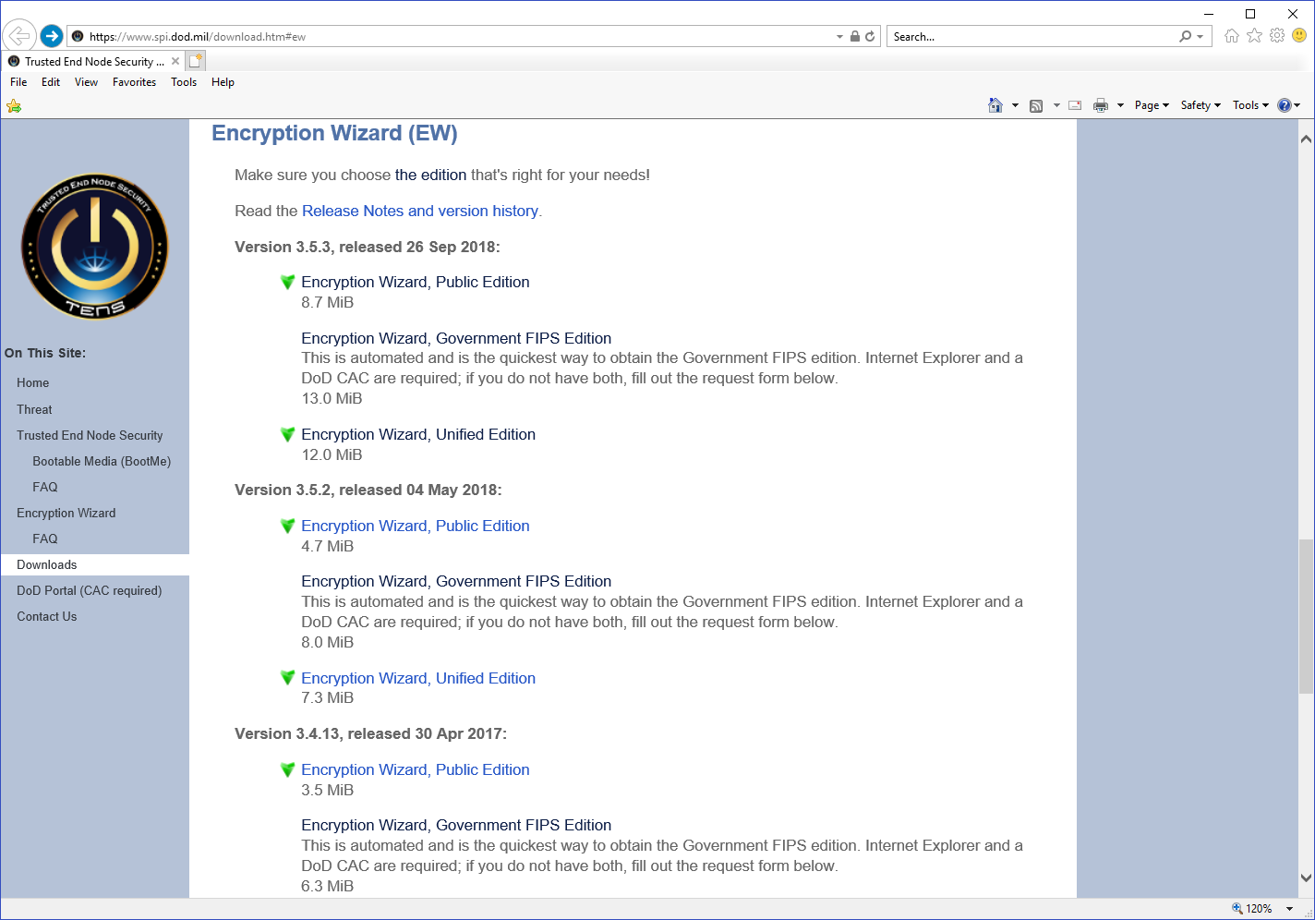

3. System will prompt you to use your CAC click “Ok”

4. Encryption Wizard window will open, select “Latest Version”

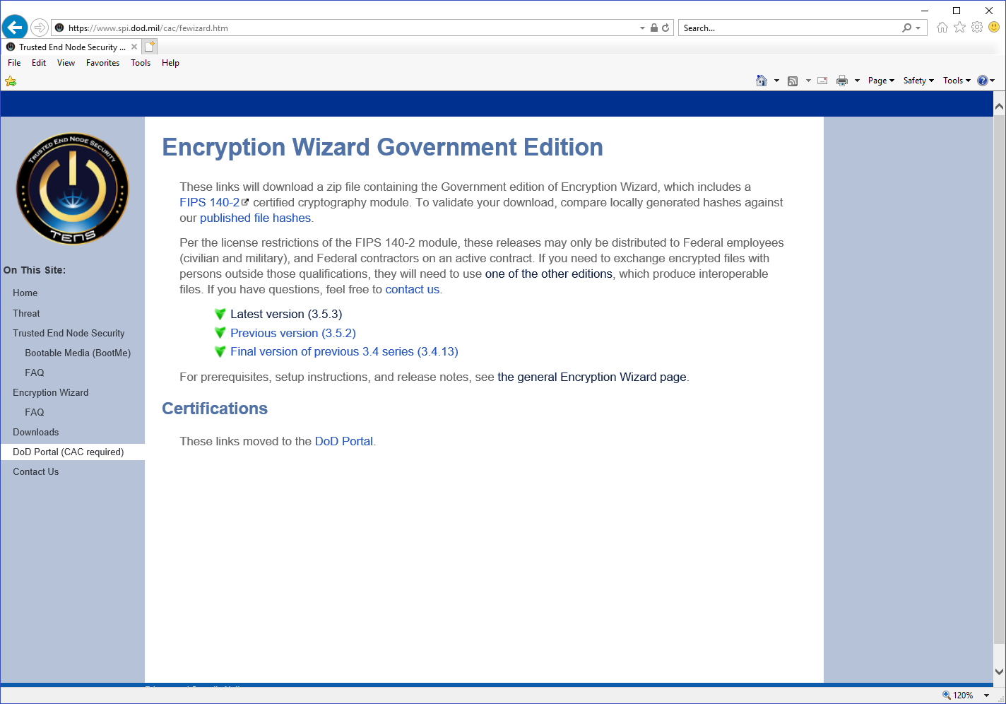

5. Click “Open” to download the Encryption Wizard will start automatically

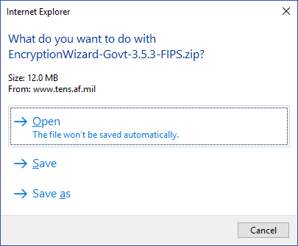

6. System will prompt you for the CAC again, click “Ok

7. Click on “Encryption Wizard, Government FIPS Edition” to unzip the folder/open the folder

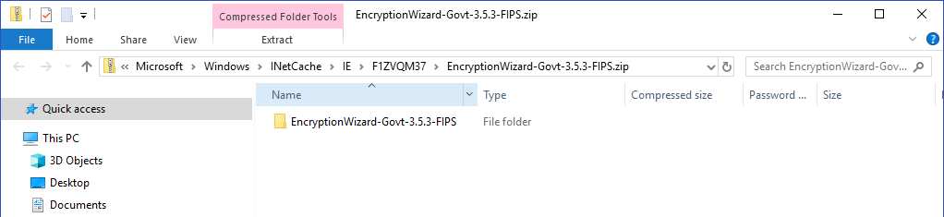

8. Double-click “EW-Govt-3.5.3-FIPS.jar file to start the Encryption process.

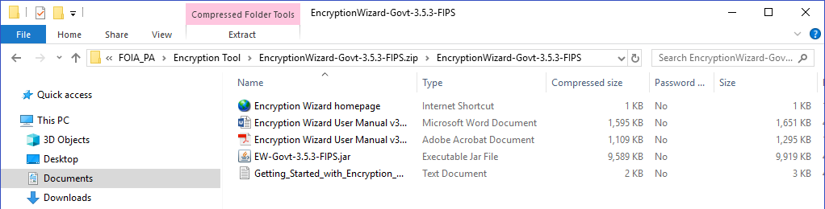

- The Trusted End Node software will start to open

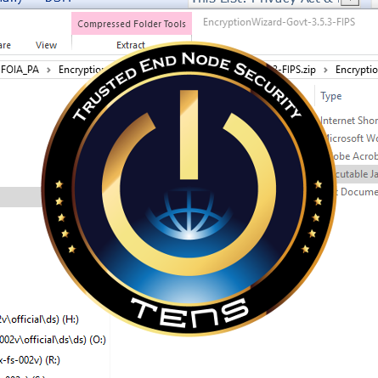

10. Encryption Wizard window will open

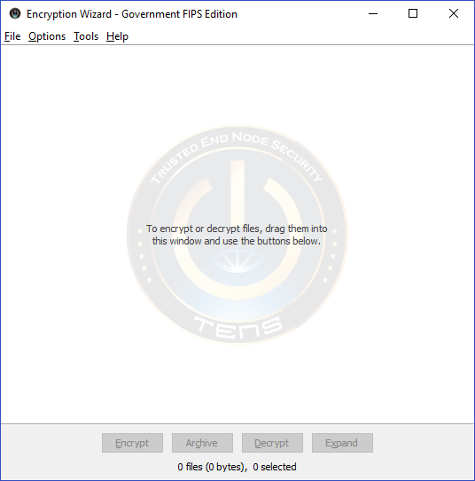

- Drag-and-drop file(s) wanting to encrypt into the Encryption Wizard box

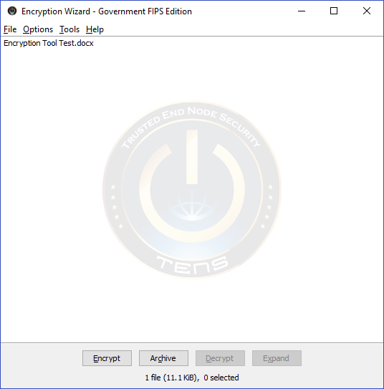

- Click 'Encrypt'

13. Enter password of your liking; this password will have to be used when decrypting the document. Send password via encryption email to your customer to be able to decrypt the file

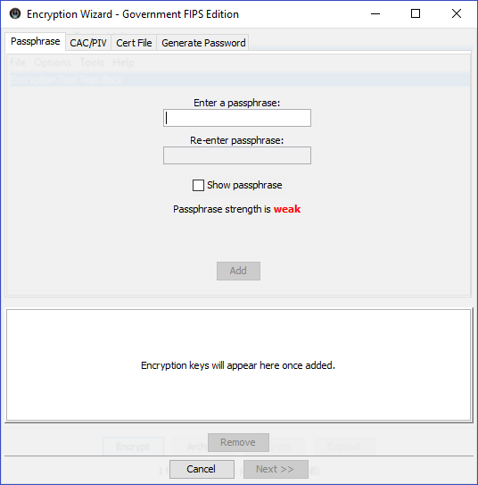

- Click “Add”. The “Next” will darken and now you’re able to click it.

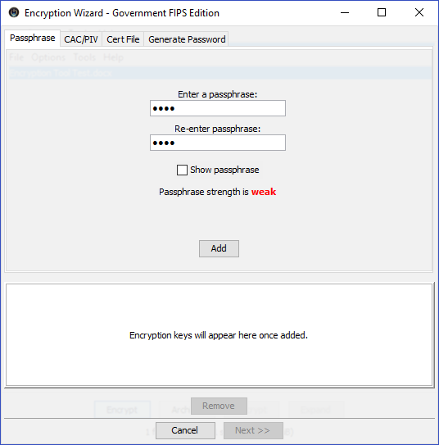

15. Enter information requested or click “Skip”

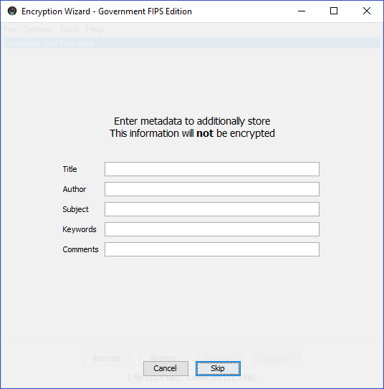

16. System will ask you to keep or delete original file(s); up to the user

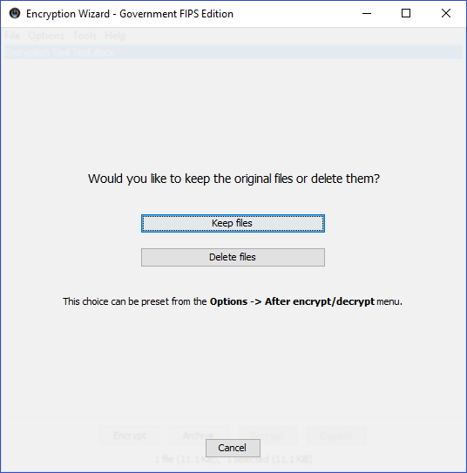

17. Your file is now encrypted. Click “Ok”

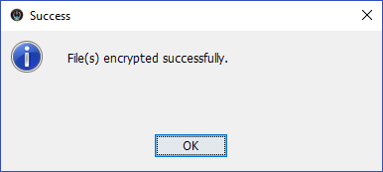

18. File will have a .wzd extension. This is the file you will upload into AMRDEC to transmit to your customer. The file is located in the same folder that the original document was when it was dragged into the Encryption box, step 8 above.

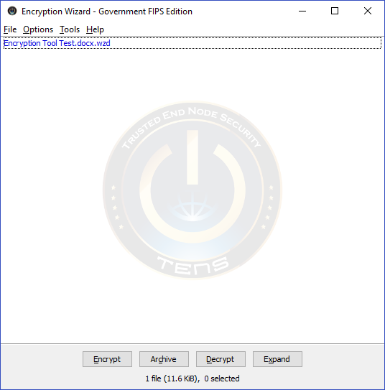
19. To be able to decrypt, the user needs to have downloaded the Encryption Wizard as well. To decrypt, drag the .wzd file into Encryption Wizard and click 'Decrypt'.

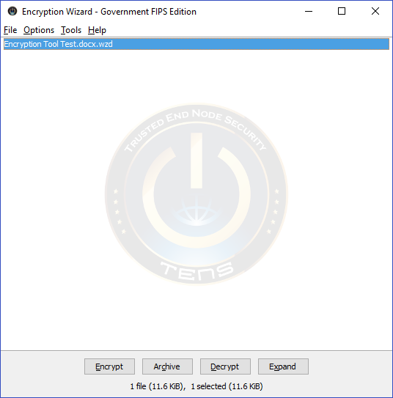

20. The system will ask you for the password the originator created when they encrypted the file. Enter the password in the box, and click “Ok”.

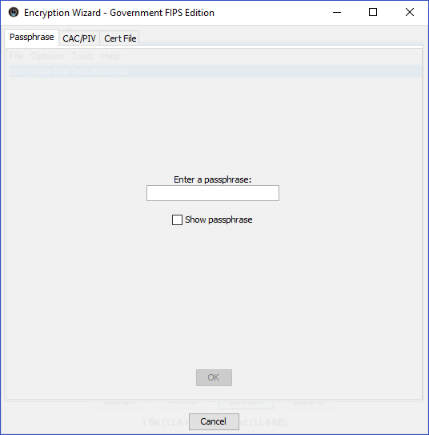

21. System will ask you if you want to keep the original files or delete them, up to the user.

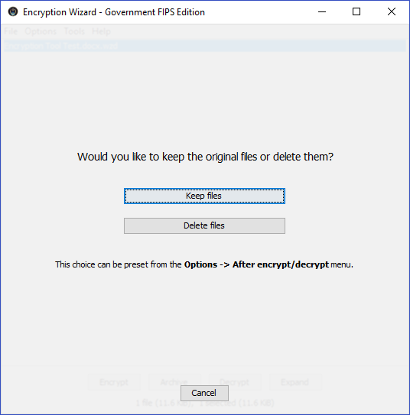

22. System will ask you to confirm the above action

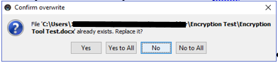

23. System will begin to decrypt the file

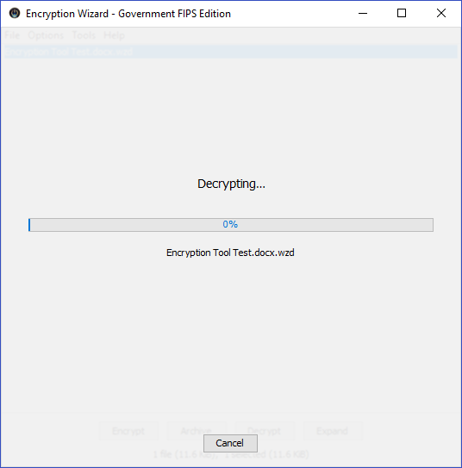

24. File is now decrypted, click “Ok”.

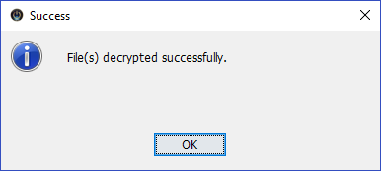

C. How to Use the Public Encryption Wizard Edition

1. Must download Encryption Wizard from https://www.spi.dod.mil/download.htm#ew

2. Under Encryption Wizard, version 3.5.3, released date 26 Sep 2018; select the Encryption Wizard, Public Edition

3. Click “Open”.

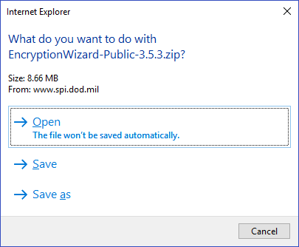

4. New menu will open showing the “EncryptionWizaard-Public-3.5.3 folder

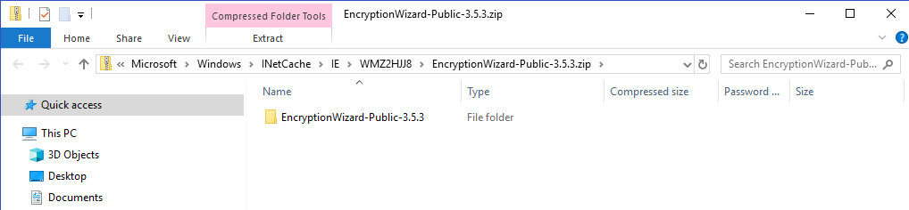

5. Double click to open folder

6. Double click on “EW-Public-3.5.3.jar file to start the Decryption process.

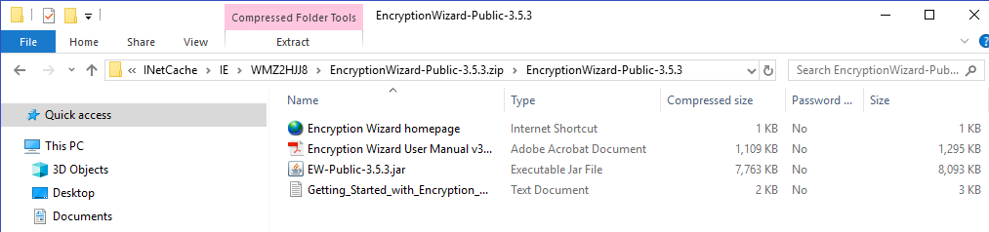

7. The Trusted End Node software will start to open

8. Encryption Wizard window will open

9. Drag-and-drop file(s) wanting to decrypt into the Encryption Wizard box. This is the file with the .wzd extension

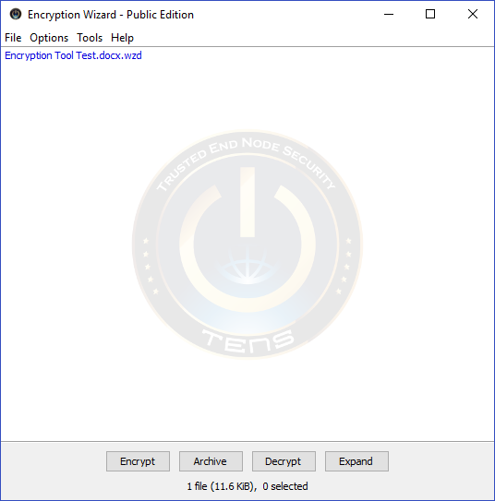

10. Click 'Decrypt'

11. The system will ask you for the password the originator created when they encrypted the file

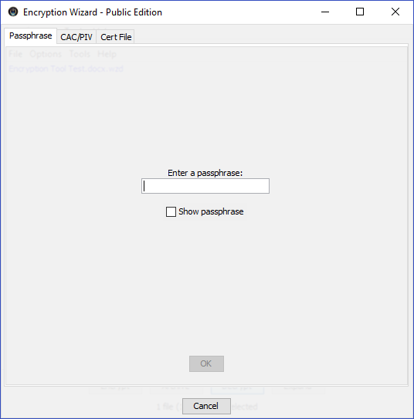

12. Enter password and click “Ok”

13. System will ask you to keep or delete original file(s); up to the user

14. System will ask you to confirm the above action

15. System will begin to decrypt the file

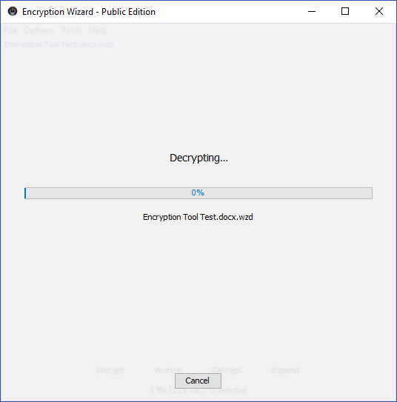

16. File is now decrypted, click “Ok”

17. Decrypted file is located in the folder where the .wzd was located when it was dragged into the Encryption Wizard box.

D. For More Information

Consult the Help menu within the Encryption Wizard or https://tens.af.mil (if you have trouble viewing this website, see http://www.getTENS.online for solutions)

====================================================================
REFERENCES:
AFI 33-332, The Air Force Privacy and Civil Liberties Program
POC: AFPC/DSMIF FOIA/PA Office, 565-2751 or afpc.ds1f.foia.pa@us.af.mil

APPENDIX L - OPERATIONS SECURITY (OPSEC)

Operations Security Guidance for Family Members

As a family member of the military community, you are a vital player in our success and we could not do our job without your support. You may not know it, but you also play a crucial role in ensuring your loved ones’ safety just by what you know of the military’s day-to-day operations. You can protect your loved ones by protecting the information that you know. In the military this is known as “Operations Security” or OPSEC.

What is OPSEC? OPSEC is keeping potential adversaries from discovering critical Department of Defense information. As the name suggests it protects US operations – planned, in-progress and completed. Success depends on secrecy and surprise so the military can accomplish the mission more quickly and with less risk. Enemies of freedom want this information, and they are not just after the military member to get it. They want you, the family member.

Unofficial Websites: The posting of pictures and information that is pertinent to your loved one’s military unit to personal or family websites has the potential to jeopardize their safety and that of the entire unit. The bottom line is to use common sense and keep your loved ones safe on the front lines.

There are many countries and organizations that would like to harm Americans and degrade US influence in the world. It is possible and not unprecedented for spouses and family members of US military personnel to be targeted for intelligence collection.

- Be Alert. Foreign Governments and organizations can collect significant amounts of useful information by using spies. A foreign agent may use a variety of approaches to befriend someone and get sensitive information. This sensitive information can be critical to the success of a terrorist or spy, and consequently deadly to Americans.

- Be Careful. There may be times when your spouse cannot talk about the specifics for his or her job. It is very important to conceal and protect certain information such as flight schedules, ship movements, temporary duty locations and installation activities, just to name a few. Something as simple as a phone discussion concerning where your spouse is going on temporary duty or deploying can be very useful to US adversaries.

- Protecting Critical Information. Even though this information may not be secret, it is what the Department of Defense calls “critical information.” Critical information deals with specific facts about military intentions, capabilities, operations or activities. If an adversary knew this detailed information, US mission accomplishment and personnel safety could be jeopardized. It must be protected to ensure an adversary doesn’t gain a significant advantage. By being a member of the military family, you will often know some bits of critical information. Do not discuss them outside of your immediate family and especially not over the telephone.

APPENDIX M - SUPPORTING FAMILIES DURING DEPLOYMENT

The AF lifestyle is punctuated by separations due to deployments, mobilizations, TDYs, remotes or crisis situations. Whether family separations are planned or unexpected, the KS assists families by keeping the lines of communication open and providing assistance in finding resource information. The active duty A&FRC Readiness NCO can provide additional resources for each stage and a calendar of on-going and/or monthly activities available.

STAGE 1: PRE-DEPLOYMENT
- Typically 4 to 6 weeks before the member deploys
- Both military member and spouse may fear separation
- Remaining spouse may feel resentment and frustration
- The member and spouse may experience physical and mental exhaustion
- May experience depression or physical problems
- Spouse may become distant and withdraw
- Feelings of disorganization and sadness are common
- Children may react by withdrawing or misbehaving

STAGE 2: DEPLOYMENT
- Once a routine is established there is relative calmness
- It is common for a sense of emptiness to set in during separation
- Old routines are gone and are replaced with new ones
- Spouses may begin to feel confident with success in handling everything
- Setbacks may occur due to additional stressors

STAGE 3: RE-DEPLOYMENT (PREPARATION FOR RETURN TO HOME STATION)
- The transition from the deployed environment (30 days prior to reintegration) to family and workplace
- Member will receive opportunities to prepare for return at deployed location (reintegration education and information)
- Family members receive opportunities for education & information on reintegration through base helping agencies
- Getting the house and family ready for the member’s return may be exhausting
- Members and spouses will have expectation about the return and both will have expectations (roles & responsibilities, parenting, rest/relaxation, intimacy)

STAGE 4: REUNION/REINTEGRATION (POST-DEPLOYMENT)
- This stage can be the most difficult
- Members may be exhausted from their deployment
- Members and spouses may experiences differences between homecoming expectations and homecoming realities (responsibilities, parenting, relaxation, intimacy)
- Communication is the key to reintegration
- Much work will need to be done to reestablish the expectations
- It is common for spouses to gain a greater sense of independence during deployment
- There may be tension when reestablishing roles and expectations

DEPLOYMENT CYCLE FOR NATIONAL GUARD AND RESERVE
The deployment cycle for National Guard and Reserve service members is similar to that of active duty service members, with slight differences at the beginning and end of the cycle. It is important to know that Individual Augmentee (IA) deployment happens when the service member deploys individually or with a small group from a different unit. These members usually have shorter notification times, lack specific information concerning their deployment and are often deployed to areas that present communication challenges. This can cause additional stressors to the ones listed above. The Key Spouse training will address this.

STAGE 1: PRE-DEPLOYMENT (Same as Regular Air Force, RegAF)
STAGE 2: DEPLOYMENT (Same as RegAF)
STAGE 3: POST DEPLOYMENT (Preparation for return to home station for emotional or physical issues as a result of the deployment)
STAGE 4: DEMOBILIZATION (Preparation for return to home station for personnel and equipment in preparation for return to non-active duty status)
STAGE 5: REINTEGRATION (Same as RegAF)

HELPFUL TIPS BEFORE TDY/DEPLOYMENT
- Organize documents
- Utilize a deployment checklist
- Obtain a Power of Attorney
- Update wills and benefits (Service Member’s Group Life Insurance – SGLI)
- Review/update Family Care Plan
- Outline family and household responsibilities
- Plan vehicle/household maintenance
- Discuss finances
- Determine child/family member/pet care
- Notify the school
- Determine a communication plan (Skype, phone, text, email frequency)
- Plan for special occasions (birthdays, holidays, graduations, etc.)

HELPFUL TIPS FOR PARENTING DURING DEPLOYMENT

- Keep children informed
- Maintain a stable environment
- Establish a routine/be consistent
- Foster a sense of security
- Engage children in family reintegration activities
- Maintain virtual connection to the deployed parent
- Include deployed parent in special events

HELPFUL TIPS FOR REUNION/REINTEGRATION

- Be flexible and adapt to changes in plans
- Involve everyone in planning the reunion
- Take it slow

APPENDIX N - NATURAL AND MANMADE DISASTERS

A significant catastrophic event, either natural or man-made, has the potential to damage or destroy an Air Force installation and surrounding communities and impact military members and their families. A catastrophic event could produce mass casualties and displace members and their families from their homes, schools, and places of employment. Community services normally available could be disrupted or rendered incapable of supporting recovery. The A&FRC is a focal point for helping the installation community address, prepare for, and respond to crisis situations.

A Wing Commander may activate the Emergency Family Assistance Center (EFAC) in situations where the anticipated needs are beyond the capability of the agencies primarily tasked to provide immediate crisis intervention. The EFAC operates 24/7 and is staffed by (but not limited to) the A&FRC, Medical Group, Mental Health, Chaplain, Finance, Legal and volunteers.

Upon activation the EFAC activities are coordinated by the A&FRC. The EFAC is a consolidated staging area where members and their families can obtain disaster relief and support, to include: information and referral related to medical, housing, financial assistance, counseling, spiritual support and crisis information updates.

Unit commanders should discuss the role of both Key Spouse Mentor and Key Spouse in crisis response. This should include possible scenarios dealing with the possibility of power outages, cell phone outages, acts of nature or terrorism, mass casualty, and evacuations. The Unit KS Team should discuss and formulate a unit plan of action. The KS may be inundated with calls from unit spouses/families searching for information. It is essential that rumors on injuries, fatalities or damages ARE NOT confirmed by the Key Spouse Mentor or Key Spouse. The installation Public Affairs office will coordinate with Wing leadership on the release of official information and statements.

APPENDIX O - AIR FORCE PERSONNEL ACCOUNTABILITY AND ASSESSMENT SYSTEM (AFPAAS)

What is AFPAAS?
AFPAAS is the Air Force Personnel Accountability and Assessment System. It is accessed through a user-friendly website designed to help Air Force personnel and their families who are directly affected by a widespread catastrophic event such as wildfires, hurricanes, floods and earthquakes.

Why is AFPAAS Important?
AFPAAS has two sides: the Personnel Accountability Element and Needs Assessment Capability.

- Accountability
- Enables Air Force leadership and authorities to account accurately for all assigned personnel and their family members, as well as make better decisions in supporting you and your family, maintaining military readiness, and preserving National Security during a disaster
- Allows you to report your current and/or displaced location in the case of an evacuation, and update emergency personal contact information
- Completing the accountability portion of AFPAAS is mandatory when directed by AF leadership; however, it is recommended members and their families provide regular updates as needed

- Needs Assessment
- Completing a needs assessment helps the AF know how you are doing and what type of type of assistance, if any, you are requesting. The needs assessment allows families to identify their needs, including, but not limited to medical, missing family locator, transportation, housing; personal property, and financial assistance.
- The AFPAAS needs assessment capability allows A&FRC Case Managers assist in recovering from a crisis and coordinate with applicable agencies in responding to needs.

Who Can Use/Access AFPAAS?
AFPAAS is available to all Air Force affiliated personnel and their family members. This includes:
- Active duty (RegAF)
- Select Reserve
- DAF and NAF civilians
- AF OCONUS contractors
- Family members, including personnel on temporary duty status, on leave or on a pass in the affected area.

How Can You Access AFPAAS?
AFPAAS requires you to have access to the public Internet, using a personal or public computer, or a smartphone with access to the Internet.


How Do You Log In To AFPAAS?
To access AFPAAS you will need to go to https://afpaas.af.mil. You may log in using your Common Access Card (CAC) or Username and Password. The username is the sponsor’s military email address. The password is the sponsor’s Date of Birth and last 4 of their SSN. Please note that this is the default username and password.

If you have you have difficulties with the username/password, you will be able to reset to the default by clicking the link, “I don’t know my username/password.”

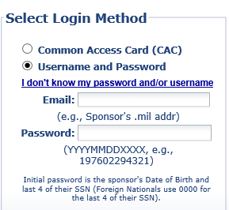

For more detailed instructions on how to access AFPAAS please utilize the AFPAAS Airman User Guide v.2.0 located in the AFPAAS “Help” tab via https://afpaas.af.mil.

APPENDIX P - SUICIDE PREVENTION AWARENESS

A person at acute risk for suicidal behavior most often will show warning signs, such as: threatening or talking of wanting to hurt or kill him/herself; looking for ways to kill him/herself by seeking access to firearms, pills, or other means; and/or talking or writing about death, dying or suicide. If at risk behaviors are observed, seek help as soon as possible by contacting a mental health professional or calling 1-800-273-TALK (8255) for a referral.

Website Resources:
https://suicidepreventionlifeline.org
http://www.dspo.mil/
http://www.wingmanonline.org/Home
https://afsp.org/

Warning Signs include:

- Increased substance (alcohol or drug) use
- Dramatic mood changes
- No reason to live
- No sense of purpose in life
- Anxiety/agitation/hopelessness
- Unable to sleep or sleeping all the time,
- Feeling trapped (like there is no way out)
- Withdrawing from friends, family and society
- Rage, uncontrolled anger, seeking revenge acting reckless or engaging in risky activities, seemingly without thinking

A Key Spouse / Key Spouse Mentor should take immediate action to inform the appropriate authority if someone exhibits or discloses suicidal ideation. If a KS/KSM receives a crisis call, it is vital to:

- Remain calm and focused
- Get the person’s name, location, and phone number
- Keep the caller on the phone while someone else calls the police
- Call or have someone else call 9-1-1
- Reassure the victim that assistance is on the way
- Stay on the phone until help arrives
- Contact the commander/unit leadership
- Always take the threat of suicide seriously

APPENDIX Q - RESOURCES

Accompanied Tour:
A tour of duty/assignment with family members

Air Force Aid Society, or AFAS
The official charity of the Air Force provides educational and financial assistance, including emergency loans and grants to Air Force members. The Airman &Family Readiness Center at your installation has AFAS (www.afas.org) representatives to assist you.

Air Force Assistance Fund, or AFAF
Annual campaign to raise money for four official Air Force charitable organizations.

Air Force Families Forever, or AFFF
Offers support for survivors who are grieving the death of an Airman. Consultants at the Airman and Family Readiness Center assist with a variety of matters as family members navigate their grief journey and adapt to life without their loved one.

Air Force Medical Service—Resources on Suicide Prevention
The Air Force Medical Service (https://www.airforcemedicine.af.mil/SuicidePrevention/) provides information on risk factors, warning signs, protective factors, helping and crisis resources, leader resources, family resources, training, and government partners in helping to effectively raise awareness about suicide prevention.

Air Force Gold Star Program
Provides enhanced support and outreach for the lifetime of each survivor, or until the survivor no longer needs or desires the services. The program lets families know that the Air Force cares for them and will continue to embrace them as part of the Air Force family. Gold Star Families fall under the umbrella of the Air Force Families Forever program and are eligible survivors of service members who lost their lives during any armed hostilities, which included deployment in support of military operations against the enemy or during a terrorist attack.

Air Force Personal Accountability and Assessment System, or AFPAAS
AFPAAS (afpaas.af.mil) manages and monitors the recovery process for personnel and their families affected and/or scattered by a wide-spread catastrophic event.

Air Force Wingman Online-Suicide Prevention
Wingman Online (www.wingmanonline.org/home) offers videos, helping resources, discussion starters and leadership tools to recognize individuals in need of help.

American Academy of Child and Adolescent Psychiatry
The mission of AACAP (www.aacap.org) is the promotion of the healthy development of children, adolescents and families through advocacy, education and research.
American Foundation for Suicide Prevention
Established in 1987, the American Foundation for Suicide Prevention, or AFSP (www.afsp.org) is a voluntary health organization that gives those that suicide affects a nationwide community empowered by research, education and advocacy to act against this leading cause of death.

American Red Cross, or ARC
The ARC (www.redcross.org) provides services to military members and their families including emergency communications, financial assistance and disaster preparedness.

Basic Allowance for Housing (BAH)
Provides uniformed service members accurate and equitable housing compensation based on housing costs in local civilian housing markets.

Basic Allowance for Subsistence (BAS)
Meant to offset costs for a member's meals. Each year it is adjusted based upon the increase of the price of food per the USDA food cost index.

Blended Retirement System, or BRS
The BRS (militarypay.defense.gov/BlendedRetirement) is a new military retirement system that blends a defined benefit annuity with a defined contribution plan through the Thrift Savings Plan, or TSP.

Child Abuse
“The physical or sexual abuse, emotional abuse, or neglect of a child by a parent, guardian, foster parent, or by a caregiver, whether the caregiver is intra-familial or extra-familial, under circumstances indicating the child’s welfare is harmed or threatened. Such acts by a sibling, other family member, or other person shall be deemed to be child abuse only when the individual is providing care under express or implied agreement with the parent, guardian, or foster parent” (DoDI 6400.06).

Defense Suicide Prevention Office, or DSPO
The Defense Suicide Prevention Office (www.dspo.mil) provides advocacy, program oversight and policy for Department of Defense suicide prevention, intervention and post-intervention efforts to reduce suicidal behaviors in service members, civilians and their families. Help is also available through the Military/Veterans Crisis Line at 1-800-273-8255.

DoD Safe Helpline
The DoD Safe Helpline (https://safehelpline.org/) is a crisis support service for the DoD community affected by sexual assault. The service is confidential, anonymous, secure and available 24/7 over the internet or via the helpline at 877-995-5247.

Domestic Abuse, or DA
A pattern of behavior resulting in emotional or psychological abuse, economic control or interference with personal liberty that is directed toward a person who is a current or former spouse, a person with whom the abuser shares a child in common, or a current or former intimate partner with whom the abuser shares or has shared a common domicile.

Domestic Violence, or DV
The use, attempted use or threatened use of force or violence against a person, or a violation of a lawful order issued for the protection of a person who is a current or former spouse, a person with whom the abuser shares a child in common, or a current or former intimate partner with whom the abuser shares or has shared a common domicile.

Emergency Family Assistance Center, or EFAC
A center, which could be co-located within the Airman and Family Readiness Center or another location either on or off an installation that serves as a consolidated staging area where members and their families can obtain disaster relief and support, to include: information and referral related to medical, housing, financial assistance, counseling, spiritual support and crisis information updates. An EFAC can operate 24/7 and is staffed by, or but not limited to the A&FRC, Medical Group, Mental Health, Chaplain, finance, legal and volunteers. When the installation Commander activates the EFAC, the A&FRC coordinates activities.

Employee Assistance Program, or EAP WorkLife4You
The Employee Assistance Program (www.FOH4You.com, Registration Code: USAF) provides Air Force civilians and their family members with valuable information, educational materials, resources and self-assessments on key behavioral health topics, including depression, anxiety, alcohol abuse, relationship issues and health and wellness, to help employees live healthy and work well. Help is also available on their helpline at 1-800-222-0364.

Exceptional Family Member Program, or EFMP
The Exceptional Family Member Program (https://www.militaryonesource.mil/family-relationships/special-needs) works with military families with special needs to address their unique medical and educational needs through the AF's integrated three component process. EFMP-Medical, EFMP-Assignments and EFMP-Family Support work as a team toward a common goal of providing comprehensive and coordinated support to families.

EX-POSE: Ex-Partners of Service Members for Equality
A national, non-profit, volunteer organization composed of former military spouses and the primary information resource for spouses facing separation and/or divorce from a military service member. EX-POSE (www.ex-pose.org) promotes the interests of former spouses of all Armed Services personnel and educates ex-partners and the public on issues of separation and divorce from military service members.

Family Child Care Program
These programs provide child care in a licensed provider’s home.

Federal Emergency Management Agency, or FEMA
FEMA (www.fema.gov) provides the most current and up-to-date disaster preparedness information available.

First Sergeant, or CCF
A key member of every squadron, the First Sergeant, or “Shirt” as he or she is sometimes called, is a senior non-commissioned officer who has received specialized training in dealing with “people issues.” The First Sergeant works directly for and with the Squadron Commander. He or she is knowledgeable about on-base resources available to assist in finding answers/solving problems, as well as managing the recognition of active duty military members’ superior performances. The First Sergeant also responds to emergencies within his/her squadron.

Key Spouse of the Year Award (KSOY)
Is an Air Force-level annual award recognizing the critical role Key Spouses play in the wing/unit/organization’s mission success and the outstanding services the Key Spouse provided to benefit the unit’s mission. The KSOY award is not designed to recognize Key Spouses for a single act or Key Spouse Mentors, but to encourage units in recognizing Key Spouses' for achievements and performance of Key Spouse duties in developing meaningful connections within the community, improving unit family cohesion, and outstanding accomplishments and contributions to overall mission accomplishment. Call for nominations to each Major Command typically occurs in December, with the inclusive period for this annual award being 1 January through 31 December.

Macho Spouse
Macho Spouse (www.malemilspouse.com) is an online resource and informational hub for male military spouses; a positive, pro-active project to help men deal with current military-life issues using video, online networking and communication.

Military Family Life Counseling, or MFLC
This Department of Defense program provides no-cost short-term, situational, problem-solving, non-medical, “walk-around” and face-to-face life counseling services to active duty military members serving in all branches of the military, as well as the National Guard and Reserves, and their family members. Counseling services span relationship, crisis intervention, stress management, grief, occupational and other individual and family issues. For more information, contact local installation family centers on Air Force and Army installations.

MilitaryKidsConnect
MilitaryKidsConnect (https://militarykidsconnect.dcoe.mil/) is an online community of military children (ages 6 to 17 years old) that provides access to age-appropriate resources to support children from pre-deployment through a parent’s or caregiver’s return.

Military OneSource
Military OneSource (https://www.militaryonesource.mil) is a confidential DoD-funded program providing comprehensive information on every aspect of military life at no cost to active duty, National Guard and Reserve members and their families. Access online or through the free hotline at 1-800-342-9647.
Modern Military Association of America, or MMAA
Modern Military Association of America (https://modernmilitary.org/) is the nation’s largest organization of LGBTQ (Lesbian, Gay, bisexual, transgender, and queer (or questioning)) service members, military spouses, veterans, their families and allies. MMAA is a non-partisan, non-profit (501c3) organization, working to make a real difference in the lives of our modern military families through education, advocacy and support. They provide free, direct legal services for the LGBTQ and HIV+ military and veteran community.

My Air Force Benefits
My Air Force Benefits (https://myairforcebenefits.altess.army.mil/) assists Airmen and their families, wounded warriors and survivors with managing their financial future. Airmen of all components (Active Duty, Guard and Reserve) should use this comprehensive site to retrieve estimates for retirement pay, deployment pay, survivor benefits and much more. The site also offers a help desk from Monday to Friday, 0900-1700 ET. Call (703) 286-2560 to speak with a military benefits specialist.

National Alliance on Mental Illness, or NAMI
NAMI (www.nami.org) is a non-profit, self-help, support and advocacy organization of individuals with mental disorders and their families.

National Child Traumatic Stress Network, or NCTSN
Congress created the NCTSN (https://www.nctsn.org/) in 2000 as part of the Children’s Health Act to raise the standard of care and increase access to services for children and families who experience or witness traumatic events. This unique network of frontline providers, family members, researchers, and national partners is committed to changing the course of children’s lives by improving their care and moving scientific gains quickly into practice across the U.S. The Substance Abuse and Mental Health Services Administration, or SAMHSA administers the NCTSN in coordination with the UCLA-Duke University National Center for Child Traumatic Stress, or NCCTS.

National Military Family Association, or NMFA
The National Military Family Association (www.militaryfamily.org) provides information and resources, including articles and links for military families.

National Military Family Association’s Finding Common Ground: A toolkit for Communities Supporting Military (Toolkit) (www.militaryfamily.org/publications/community-toolkit/)

National Resource Center for Healthy Marriage and Families
The National Resource Center for Healthy Marriage and Families (www.HealthyMarriageandfFamilies.org) is a service of the Office of Family Assistance, Administration for Children and Families, U.S. Department of Health and Human Services, which offers a variety of tools and resources designed to educate interested stakeholders in the benefits of integrating healthy marriage education into existing social service systems. The Resource Center also provides a range of training, services, and support to interested State, Local and Tribal government agencies as they work to integrate these healthy marriage and relationship skills into their existing services in order to best support the families in their communities.

National Suicide Prevention Lifeline
The National Suicide Prevention Lifeline (www.suicidepreventionlifeline.org) is available 24 hours a day, seven days a week and is free and confidential. Help is also available via the lifeline at 1-800-273-TALK, or 8255.

Operation Homefront
Operation Homefront (www.operationhomefront.org/) is a nonprofit organization that provides emergency financial, disaster recovery assistance, transitional housing, back to school supplies and other assistance to the families of service members and wounded warriors.

Ready.Gov
Ready.gov (https://www.ready.gov/) is a Department of Homeland Security site that provides information on planning ahead and taking action for any disaster. For Air Force-specific resources, visit the Be Ready site (www.beready.af.mil).

S.A.F.E. Alternatives
S.A.F.E (https://www.selfinjury.com) provides information about self-injury and treatment information. Help is also available via the S.A.F.E. information line at 1-800-DONTCUT, or 366-8288.

Servicemembers' Group Life Insurance, or SGLI
Low-cost group term life insurance for service members on active duty, ready reservists, members of the National Guard, members of the Commissioned Corps of the National Oceanic and Atmospheric Administration and the Public Health Service, cadets and midshipmen of the four service academies and members of the Reserve Officer Training Corps.

Sexual Assault Prevention and Response, or SAPR
The day-to-day mission of the Air Force SAPR Program (https://www.af.mil/SAPR/) is to educate, advocate and collaborate to respond to and stop sexual assault and its harmful effects on the Air Force.

Sexual Assault Response Coordinator, or SARC
The SARC serves as the installation’s primary point of contact for integrating and coordinating sexual assault victim care services for eligible recipients. Services may begin at the initial report of sexual assault and continue through disposition and resolution of issues related to the victim’s health and well-being. Visit the DoD Safe Helpline (https://safehelpline.org/search.cfm) to locate the SARC closest to your location or contact the DoD Safe Helpline at 877-995-5247.

Spouse Education and Career Opportunities, or SECO
SECO (https://myseco.militaryonesource.mil) is a DOD program that delivers a comprehensive education and career solution for military spouses pursuing training, jobs and sustainable careers by providing career services and connecting them to employers seeking employees with the 21st century workforce skill sets possessed by military spouses.

Survivor Benefit Program, or SBP
The Survivor Benefit Program is an insurance plan that will pay a deceased retired Airman’s survivors a monthly payment, or annuity, to help make up for the loss of retirement income when retired Airman dies. The plan protects survivors against the risks of early death or survivors outliving the benefits. It is important to note that when a retired Airman dies, their retirement pay stops. It is critical for spouses to understand this when they accept or decline the SBP at the time of an Airman’s retirement. The law requires spouses to concur in writing prior to the member’s date of retirement if the member elects less than full coverage. Use My Air Force Benefits (www.MyAirForceBenefits.us.af.mil) or visit your Airman and Family Readiness Center’s SBP counselor to ensure you understand this benefit.

The Defense Center of Excellence, or DCoE
The DCoE (t2health.dcoe.mil) Provides personalized consultation 24/7 to help service members, veterans, families, caregivers and health care providers access psychological health and information and resources.

The Military Crisis Line, or MCL
The MCL (www.dspo.mil) is a group of caring, qualified responders from the VA who relate to service members and their loved ones’ experiences and challenges. Help is also available via their hotline at 1-800-273-8255.

Tragedy Assistance Program for Survivors, or TAPS
An organization that is dedicated to supporting anyone and everyone whom a service member’s active-duty death has affected. TAPS provides, at no cost to the survivor, a national peer support network, grief-counseling referral service, crisis intervention, or 24 hours a day and case worker assistance. You may call 1-800-368-TAPS, or 8277 to speak with a TAPS counselor or visit the TAPS website (www.taps.org). They also publish a quarterly newsletter.

TRICARE
The health care program of the United States Department of Defense Military Health System. TRICARE (www.tricare.mil/) provides health benefits for U.S Armed Forces military personnel, military retirees and their dependents, including some members of the Reserve Component.

U.S. Department of Agriculture
The U.S. Department of Agriculture’s (www.fns.usda.gov/outreach/getinvolved/military.htm) website has information and pre-screening tools for military families for food programs, including Supplemental Nutrition Assistance Program (SNAP) and Women, Infants, and Children (WIC – a federal or state program to ensure proper nutrition for low-income pregnant, breastfeeding, and non-breastfeeding postpartum women, and to infants and children under the age of five).

Volunteer Excellence Award (VEA)
The VEA is a United States Air Force Chief of Staff level-award. The VEA was established to recognize federal civilians, family members, military retirees and federal retirees who perform outstanding volunteer community service of a sustained, direct and consequential nature. The VEA considers long-term volunteerism over a number of years, which positively impact a military installation or surrounding community. It is intended to recognize exceptional long-term community support and not a single act or achievement. Call for nominations for this annual award are usually solicited by the installation A&FRC in late January/early February.

vRED Form
This form, also known as the DD Form 93, Record of Emergency Data is the official source document required by law for Airmen to provide emergency contact information and beneficiary designations to the AF. It shows the names and addresses of spouse, children, parents and any other person(s) the Airman would like the Air Force to notify in the event of a casualty. To keep this document current, Airmen receive an annual e-mail reminder in their birth month to update their vRed via the virtual Military Personnel Flight, or MPF on the AF Portal. Anytime an Airman goes through major changes in their life, he or she should update this document.

Volunteer Logical Access Credential, or VoLAC
An access card for the sole purpose of allowing volunteers to access DoD computers / networks. Volunteers cannot use VoLAC from non-DoD or home computers. The volunteer’s unit must request a network account on behalf of their volunteer. The complete process is in the Commanders’ Key Spouse Program Guide, as the unit CC must authorize and approve VoLAC for unit volunteers.

White House Veteran’s Affairs, or VA Hotline
VA’s first non-clinical, non-emergency, around-the-clock call center with live agents answering veteran’s needs and concerns 24-hours a day, 365 days a year at 1-855-948-2311.

Yellow Ribbon Reintegration Program
The Yellow Ribbon Reintegration Program (https://www.yellowribbon.mil/yrrp) website contains deployment cycle information, resources, programs, services and referrals for the Air National Guard and Air Force Reserve Service members and their families.

APPENDIX R - MILITARY FAMILY LIFE COUNSELOR (MFLC) PROGRAM

BACKGROUND: The MFLC program provides confidential, non-medical, short term, situational, problem-solving counseling services to service members and the families of the active duty, National Guard and Reserve regardless of activation status, Coast Guard and their families when activated for the Navy, and members of the Civilian Expeditionary Workforce and their families.

The non-medical and short-term, solution-focused counseling approach is psycho-educational, which helps participants learn to anticipate and resolve challenges associated with the military lifestyle. Support is aimed at preventing the development or exacerbation of mental health conditions that may detract from military and family readiness. There are several different types of MFLCs that may be located on the installation.

General/Adult Military and Family Life Counselors (MFLC): The MFLC assists service members and their families with circumstances occurring across the military life cycle and aims to enhance operational and family readiness. They provide support to individuals, couples, families and groups for a range of issues including, but not limited to: deployment stress, reintegration, relocation adjustment, separation, anger management, conflict resolution, parenting, parent/child communication, relationship/family issues, coping skills, homesickness, and grief and loss.

Child and Youth Behavioral (CYB MFLC); AND CYB-School MFLC: CYB-MFLCs support and augment Child and Youth Programs, Department of Defense Education Activity schools, local education agencies, National Military Family Association, Operation Purple Camps and Family Retreats, National Guard and reserve camps, and Operation Military Kids camps and Special Operations Command. The CYB-MFLCs provide non-medical support to eligible faculty, staff, parents and children for issues including, but not limited to, school adjustment, deployment and reunion adjustments, and parent-child communications. All work is conducted within staff or parent line of sight.

Personal Financial Counselor (PFC): Service members and their families can contact a PFC for assistance with personal financial readiness, money management, financial counseling and financial planning. In cases of extreme financial hardship, PFCs ensure that service members and their families are referred to the appropriate military resources such as relief societies; installation banks and credit unions; chaplains; state, federal, local and veterans’ organizations; and other resources as applicable. Located in the Airman & Family Readiness Center.

Eligible participants may receive up to 12 sessions of non-medical counseling, per issue, from MFLCs and CYB-MFLCs.

APPENDIX S - TIPS FOR OBTAINING A VOLAC

Tips for Obtaining a
Volunteer Logical Access Credential (VoLAC)

The VoLAC is solely for the purpose of gaining access to DoD computers/networks, and shall not be used for logical access from non-DoD or home computers. It is not a Common Access Card and will not display a photograph; does not convey benefits, entitlements or privileges; and cannot be used for physical access. Applicants must be U.S. citizens.

STEP 1 – The unit where the volunteer works must request a network account on behalf of their volunteer (including Key Spouses)

STEP 2 – The work unit security manager initiates a National Agency Check with Inquiries (NACI)

STEP 3 – The work unit security manager confirms the 10-fingerprint FBI check is completed; and

STEP 4 – The work unit trusted agent must create the volunteer (includes Key Spouse) enrollment application in the Trusted Associated Sponsorship System (TASS) to DEERS

STEP 5 – When DEERS enrollment is complete, the volunteer (including Key Spouses) visits the FSS Customer Service ID card issuing facility to receive his or her VoLAC. Note: Two forms of identity are required, at least one unexpired with a photo must be provided; example, state driver’s license, military ID card, or items from the “Lists of Acceptable Documents” at http://www.uscis.gov/sites/default/files/files/form/i -9.pdf

The handout was created by AFPC/DPFF & DPSIZ and is intended for units with KS/KSM and other installation volunteers requiring access to DoD computers/networks.

APPENDIX T - GUIDELINES FOR KEY SPOUSE OF THE YEAR (KSOY) AWARD

Key Spouse of the Year Award – The information provided below is for your information only. Please note that award guidelines may change from year to year and commanders should follow the guidelines in the actual call for all submissions. The information below is provided for your planning and consideration only. This is not a call for award submissions and information below was current for the last KSOY award. In the past award nominations have been due to the MAJCOM POC by mid-February.
1. Responsible Agency. MAJCOM A1
2. Purpose or Objective. Recognize the critical role KSs play in the wing/unit/organization’s mission success; enhance command KS visibility and accomplishments; encourage units to recognize KSs’ outstanding accomplishments and contributions to overall mission; and motivate Key Spouses to strive for meaningful connections within communities.
3. Eligibility. All KSs are eligible to be submitted for the award. KSMs are not eligible for this award.
4. Frequency of Award. Annually. Inclusive period for this award is generally 1 January through 31 December.
5. Nomination Procedures: Each Air Force Directorate, Wing, Numbered Air Force and Independent Group commander (if applicable) may nominate one individual from the Key Spouse Program assigned to their unit/organization. Nomination packets generally call for 30 lines with headings for Key Accomplishments and Other Accomplishments/Community Efforts on the AF Form 1206, a standard biography, official color photo, and a public release statement.
6. Selection Process. The nomination packages will be reviewed by a selection panel. The results of the panel will be approved by MAJCOM/CC or designated representative.
7. Method of Presentation. The KS will be presented a certificate of achievement at a time and place determined by the MAJCOM.
8. Travel for Non-Military Members or Non-Department of the Air Force Civilians. Travel to the presentation ceremony (if one is held) is authorized for Department of the Air Force Civilians and non-military/non-Department of the Air Force Civilian recipient.
9. Publicity. Each MAJCOM will announce their respective winner. The Air Force level Key Spouses of the Year will be comprised of the MAJCOM winners.

APPENDIX U - COMMUNICATION LOG FOR KSs and KSMs

Spouse/Key Spouse Mentor Name: ______________________
Unit: _____________
Unit Commander: _________________________ First Sergeant: ______________________

Name of Individual Contacted | Phone Number | Date | Time of Call | Length of Call | Purpose of Call | Action Taken/ Follow-Up Needed?
Private/personal information or notes on spouses/family members should NOT be documented in writing or maintained in any files.

APPENDIX V - VOLUNTEER TRACKING LOG FOR KSs and KSMs

Volunteer Name: ________________________________
Unit: ____________________

Project/Task/Event/Activity | Date(s) | Hours

APPENDIX W - KEY SPOUSE STATEMENT OF CONSENT FOR RELEASE OF PII

STATEMENT OF CONSENT

I, _______________________________ (Key Spouse name, printed) authorize release of my information (my name, home phone number, cell phone number, and personal email address) to be included in a Key Spouse Roster that will be given to other appointed Key Spouses, Key Spouse Mentors, commanders, first sergeants, other installation leaders, and families.

I consent to and request that the Airman and Family Readiness Center disseminate and email this personal information about me, as described above, on the Key Spouse Roster, including to commercial email accounts when the individual does not have access to an encrypted account.

I declare under penalty of perjury under the laws of the United States of America that the foregoing is true and correct, and that I am the person named above (requester) and I understand that any falsification of this statement is punishable under the provisions of 18 U.S.C. section 1001 by a fine of not more than $10,000.00 or by imprisonment of not more than five years or both, and that requesting or obtaining any record(s) under false pretenses is punishable under the provisions of 5 U.S.C. 552a(i)(3) by a fine of not more than $5,000.00.

_______________________________ _________________
Requesting Key Spouse Signature Date

_______________________________
Requesting Key Spouse Printed Name

Language on document not to be changed
Document developed by AFPC/JA, 2019

APPENDIX X - KEY SPOUSE PROGRAM TIPS AND SUCCESS STORIES

Many thanks to all the Senior AF Leadership Spouses, installation Key Spouses, Key Spouse Mentors, First Sergeants and Airman & Family Readiness Centers throughout the Air Force for sharing the below collection of tips and success stories.

TIPS:

- Incorporate KSs into the unit’s sponsorship program and processes, ensuring all “inbound spouses” have the information they need before arriving on the installation. Military One Source offers a “Sponsorship Awareness Training for Families” and is available through an eSAT course which can be accessed through My Training Hub.
Login to the site requires an email address and creation of a password. The course takes approximately 90 minutes to complete and can be accessed through the following link: https://myhub.militaryonesource.mil/MOS/f?p=SIS:9:812951163311203::::P9_ID:12.

- When referencing the KSP with families and military members, market the program as an information and resources support group - NOT a social club.
- Provide unit families information on Social Media etiquette, along with a link to the AF Social Media Guide, http://www.af.mil/AF-Sites/Social-Media-Sites/.
- Assess how many KSs may truly be needed in a unit by developing a ratio of KSs to unit spouses. This varies depending upon the mission of the Wing. “Our Wing set an objective of 1:50 minimum (one KS to 50 unit spouses), and a goal of 1:25 so the KSs could have strong enough relationships and frequent enough contact to pick up on the 'soft signals' (also helped get through PCS season change outs). The Mission Support Group provided us with the numbers of exactly how many spouses were assigned to each squadron and each unit commander (CC) recruited KSs to meet the 1:25 goal. Our KS numbers doubled throughout that timeframe as the unit CCs recruited towards 1:25 or better.
- To reinforce the importance of the KSP, and make it a priority, we mitigated this through a wing tracking slide which tracked metrics with a stop light chart that was reviewed monthly at Wing Standup. Items in the chart included areas such as 1.) Ratio of KS to spouses per squadron <1:100=red, <1:50=yellow; <1:25=green 2.) KS assignment/notification during sponsor process 3.) Assigned KSs to each spouse (as opposed to just a posted list they can call if they have time).
- Cross-wing exchanges are great opportunities for discussion, networking and exchanges of success stories between similar squadrons (i.e. KSs talking to other similar squadrons from other installations and wings).
- As a wing, we opened up almost all our leadership training opportunities (i.e., PACE) as an option for our KSs and KSMs to attend.
- The mayor of the local community held a “Sneak Peak Event” for KSs/KSMs informing them of upcoming community projects and events.
- Communicate benefits of the KSP (Connect, Inform, and Refer) and military members/families will be more trusting and comfortable sharing.
- Recommend that senior officer spouses not be KSs.
- KSMs are advisors/supporters, they should not be on the “front line”; primary role is mentoring and troubleshooting issues so the KS can focus on the families.
- Visibility is KEY: Invite KS to speak at CC Calls, introduce at squadron events, promote as a member of the team and share the purpose and priority of the KSP at every opportunity.
- As a CC, let your members know the KSP is a priority for you and emphasize the “official readiness” role vs. a “social” role. Social engagement is critical to build relationships, but it’s not the goal of the KSP. KSs need to portray this as well.
- Divide duties among your KSs and make sure they understand the recommended program minimums.
- Maintain a “continuity binder”.
- Familiarize new leadership with the KSP, continuity binder and set your successor up for success.
- Suggest CCs and CCFs attend a training session to learn about the KSP. Also, if CCs could attend round table discussions, they would be able to hear what some of the obstacles or problems their KSs are encountering; KSs/KSMs are one of the best assets a CC can have.
- KSs should be represented at / attend Newcomers Orientation Information Fair
- Ensure there is KS representation at each Right Start as part of WG/CC Welcome Brief.
- Establish a one-year minimum commitment from the KS/KSM and if they want to continue after a year, that’s great; but for some, it’s can be too much to commit beyond a year.
- An AF Reserve Tanker Unit provided KSs with familiarization flights as a way to say “thank you” to the KSs on base.
- KSMs conducted a KS appreciation/social event – very successful.
- Public Affairs made videos of the required continued education classes, which provided training access to working spouses, or those with prior commitments and/or children.
- KS/CCF socials were conducted at least semi-annually to discuss best practices and issues from around the base.
- Provide a monthly newsletter for squadron.
- Provide an informational KS page in the base paper or on wing Website.
- Recommend providing KSs with a mission brief on their organization/unit so they are even more familiar with unit and leadership within.
- The AF KS Guide is written clearly and if followed makes for a very successful Unit KSP. Encourage each wing to follow it thoroughly and urge squadron CC’s to interview a KS at the beginning of their command will reduce the confusion and generate a level of respect and cohesion in all squadrons.
- Collaborated with the medical group, which offered a tour of the facility, a TRICARE update and explained how to handle patient concerns with healthcare service. This training was well received by all attendees and has reduced complaints over social media.
- For CCs, waiting to create a robust KSP will not help when a crisis falls on the squadron. Striking a balance between the primary mission and establishing a KSP shouldn’t wait, as it may be too late when a crisis hits.
- Suggest having a KSM attend new squadron CC courses, allowing KSM to advocate/validate the program during the A&FRC Briefing, providing additional “real-world” insight to new CCs and their spouses.
- Highlight unit KS via an introduction flyer with names, pictures and contact information.
- Squadrons assigned a KS based on location, (i.e., if they live outside the base they were paired up with someone who lives in their local area).
- Offer KSs/KSMs training in the evening and off-site (in volunteers’ homes, if necessary) to allow greater flexibility with work and childcare concerns.
- Include foreign services units and their members/families in your KSP.
- For CCs, please recognize the hard work and dedication of your volunteer KSs. Highlight KSs in CC Calls and quarterly awards, luncheons, etc. Make them visible and important. Please help with funding business cards (perforated business card stock paper).
- Consider “back-up” KSs, like deputies. That way if a family is in the midst of a crisis, the primary KS can focus on that one family and the deputy can handle less time consuming issues.
- Don’t use a KS when it’s more important to have a CCF of CC involvement.
- Squadron conducts quarterly training meetings with KSs, in addition to the A&FRC trainings.
- KS/KSMs met quarterly with the Squadron CC to discuss/review squadron KSP and ways to strengthen/improve it.
- Offer a base-wide volunteer rewards program based on the number of hours volunteered per month. Volunteers can then earn a certain level of rewards which can be very appealing (parking pass for up front parking at the commissary or BX, free bowling, free coffee at the coffee shop, etc.). This could also help to encourage better participation in Continuing Education opportunities.
- Installation created a “Helping Agency Matrix” which was provided to all KSs and KSMs to help refer families in the right direction. It was also posted on the wing Webpage for all to access.

EXAMPLES OF SUCCESS STORIES:

- Created a KS Team Crisis Scenario Training geared towards helping CCs, CCFs, and KSs/KSMs (KS Leadership Team) get comfortable working together as a team. The concept is a mass training to get all unit KS teams in the same room, broken up at tables by squadron. It started with each table's KS being taken to another room and given one of the crisis scenarios, as if they had just received a phone call from a spouse. The KS then returned to KS team to develop a solution. At the end of the exercise, each table/KS team out-briefed the group on their particular issue/solution/pitfalls. Training forced the conversations for CCs to give their individual expectations to their own KS's; and brought the Unit KSP teams together across the wing. (Seymour Johnson AFB, North Carolina)
- Created, with local Public Affairs Office, KSP commercial/video. Please use link to view the KSP Commercial (Seymour Johnson AFB, North Carolina): https://www.youtube.com/watch?time_continue=4&v=mX7dT5TRvYE
- KSs were unsure of their roles during a Noncombatant Evacuation Operations (NEO) event, so a specific training was developed for the KSs/KSMs; NEO 201 will be presented as needed or prior to semi-annual base exercises. (Osan AB, South Korea)
- Navy Ombudsman and Army Family Readiness Groups have been included in our KS social networking group. (Misawa AB, Japan)
- Implemented Unit Spouse Sponsorship Program: Contacted inbound active duty member 3 months prior to report no later than date (RNLTD) to request spouse's name and e-mail. Contact made with inbound spouse to pair with KS and provide information regarding overseas PCS, the base and surrounding area, squadron Facebook page, etc. to give inbound spouse resources for a smooth transition and easier integration into spouse programs upon arrival. (Aviano AB, Italy)
- Unit implemented new program aimed at discovering what each unit spouse has to offer individually (artist, photography, travel, design, event organizers, playgroups, chefs, etc.) to get them involved and excited about sharing their talents in the squadron. (Aviano AB, Italy)
- Annual United Kingdom (UK) KS Symposium: Organized and hosted by a KS team made up of KS's, KSM's and senior leadership spouses from all the UK bases. The A&FRC reps from each base participate in the process/program as observers and subject matter experts on A&FRC-related areas. (RAF Lakenheath, UK)
- Unit Welcome Program: Send invitations via email, Facebook, or posting a written invitation in new spouses PO Box to attend monthly Unit Welcome Meeting. During the meeting the KS team provides new spouses with information packets and allows spouses an opportunity to put a face to the KS team members. New spouses can ask questions and network with other squadron spouses. This program also works in tandem with Unit Spouse Pre-deployment Briefings where there is an opportunity to provide resource information and ensure accurate contact information is on file in preparation for deployments. (RAF Lakenheath, UK)
- Welcome Wagon: Unit KSs travel to see new spouse and provide a little welcome basket funded by the Unit Booster Club (assembled by unit spouses). This gives KSs an opportunity to say hello and offer a face to face welcome – it has been well received. (Scott AFB, Illinois)
- Created the KS Toolkit. This is a comprehensive resource for KSs & KSMs and includes: Official program guidance, local Community Action Team (CAT) agency contact list, quick resource sheet, FAQs section, and comprehensive virtual resources. Initial distribution of the KS Toolkit (binder/paper) was given to CCFs to ensure all current KS/KSMs received one. Subsequently, the KS Toolkit is given to all KSs/KSMs during KSP Initial Training. The Toolkit is posted www.ramstein.af.mil and will only be provided electronically for more efficient updating and KS/KSMs will still be able to download a copy. (Ramstein AB, Germany)
- We are able to provide classes in town, closer to where our families live, to get better participation in trainings. We partner with local YMCA and hospital for classroom space, which also enables us to provide evening and weekend classes. (Creech AFB, Nevada)
- KSM Chat - provides a venue for mentors at all levels (squadron/group/wing/NAF) to freely discuss issues, challenges, share information, ideas and success stories. (Davis-Monthan, Arizona)
- Mentor the Mentor sessions have been eye opening for new leadership and their spouses. Created M2M to allow for KSM to share with other KSMs trials/tribulations and challenges they face as KSMs. (Whiteman AFB, Missouri)
- Offers a semi-annual KS "reset button" retreat in order to refresh. (Moody AFB, Georgia)
- Vice Wing CC attends quarterly KS trainings to obtain feedback on the needs of spouses and the families in their squadrons. (Vance AFB, Oklahoma)
- Bi-annual round table discussions with WG/CC and KSs/KSMs provides an opportunity for KSs/KSMs to share what issues are affecting families in the community directly without having to navigate through several channels. KSs/KSMs feel empowered to continue advocating for their families knowing they will be heard. (Edwards AFB, CA)
- Unit conducted a deployment social where the KS team invited all deploying members and their families with the intent of connecting families before the 6-month deployment began. The feedback was terrific and one spouse said she had never experienced an opportunity to meet with others prior to a deployment situation in her 15 years as a spouse. (Grand Forks, North Dakota)
- Group KSMs created social media outlets and monthly/quarterly gatherings for group KSs/KSMs. This has created more fluid communication and sharing of resources across the entire group. (Altus AFB, Oklahoma)
- Unit Family Calendar - A 12 month calendar issued to spouses outlining events either hosted by the unit (not the KS) or offered in the community that unit families are asked to attend together. Ex: IAAFA 75 Birthday Celebration 5K, IAAFA Wing Pinning Ceremony, San Antonio Battle of the Flowers Parade (families meet up to participate), JBSA/IAAFA Hispanic Heritage Month Celebration and IAAFA Thanksgiving Luncheon. This is a great example of integrating the social component into a unit KSP and aids in the KS not having to be an “event planner”. (Joint Base San Antonio-Lackland, Texas)
- Wing CC hosted two town hall meetings to discuss support and praise for the KSP; additionally, KSs are recognized in squadron, group and wing quarterly and annual award ceremonies. (Luke AFB, Arizona)
- Quarterly KS Forum: Allows KSs/KSMs (base wide) to discuss trends in units (phone calls, e-mail inquiries, etc.) with issues/concerns being identified and presented to the CAT. (Tinker AFB, Oklahoma)
- Wing Leadership tracks unit KS activities on a monthly basis to ensure unit members/families are utilizing KSP resources; metrics are shared during CC Calls/briefings. This validates the overall KSP and includes KSs as an integral part of the team. (Buckley AFB, Colorado)
- A KS created a “’Keyping’ Connected” resource for all KSs/KSMs which is a collection of all of the Facebook pages for all of the participating squadrons within the joint base environment. This resource is useful for referrals during informal contact situations. (Joint Base McGuire-Dix-Lakehurst, New Jersey)
- Key Spouse Program Planning Session: A two-hour session with installation A&FRC KSP Program Manager and trained KSs/KSMs to discuss what is working, new ideas, and roadblocks. (Travis AFB, California)

APPENDIX Y - COMMANDER’S KEY SPOUSE PROGRAM CHECKLIST

Key Spouse Program Basics | Notes
Review CSAF Memo
Review Memorandum from SAF/GCA to AF/A1 on: “Authority to Use Appropriated Fund to Buy Key Spouse Program Items”. Contact your local legal office Judge Advocate for a copy of this multi-page document; or your
local Airman & Family Readiness Center can provide this during initial face-to-face A&FRC Consultation within the first 90 days of assuming command of unit.
Determine unit KSP goals, along with the KS and KSM roles/responsibilities  (See pages 6-9 and 20-23) | Include appropriate KS/KSM roles in the unit disaster preparedness plan; in addition, ensure KS/KSM roles during events involving casualties are clearly identified as well.
Customize the KS and KSM Position Descriptions to reflect unit specific roles/responsibilities (See pages 20-23)
Determine the number of KSs needed to support unit (recommended ratio is 1 KS per 100 unit members)
Determine/identify additional local requirements | (ID unique needs of unit/wing/installation)
Key Spouse / Key Spouse Mentor Interviews | Due | Complete | Notes
Design the interview format (phone, in-person, panel, etc.)
Prepare a list of interview questions (See page 26)
If using a panel to interview, identify panel members and
provide each with the question list; discuss ROEs
Review candidates and schedule interview time/date
Contact candidates
Conduct interview(s)
Check references
Evaluate candidate(s)
Select KS / KSM applicant(s) who will be the best fit for the unit.
Follow up with all candidates that selection was made.
Key Spouse / Key Spouse Mentor Appointment | Due | Complete | Notes
May assign the Chief, Superintendent, CCF, SNCO, or other officer designee as the KS / KSM Program POC (note: some units may be comprised of more officers than enlisted).
Set up a volunteer file for each new KS / KSM appointee.
Introduce new appointees to the Unit KSP Team (enlisted and/or officer POCs, KSM(s) and other KS(s); provide unit tour and mission brief.
Reiterate roles/responsibilities and convey types of issues/events which can be handled by the KS / KSM versus those which should be elevated to unit leadership.
Discuss logistical supplies/support with new appointees.
Complete appointment letter(s) and forward copy to local
A&FRC KSP POC (See pages 27-28)
Ensure KS / KSM understands training requirements and completes mandatory trainings outlined in position descriptions.
Complete and maintain a Department of Defense (DD) Form 2793, Volunteer Agreement for Appropriated Fund Activities & Non Appropriated Fund Instrumentalities, on file before Key Spouse and/or Key Spouse Mentor begins performing duties IAW DoDI 1100.21, Voluntary Services in the Department of Defense. This is a “Tier 0”, non-waiver inspection item.
Meet with KS / KSM following KSP Initial Training , KSM Training or Refresher Training to validate they received a copy of the KS and KSM Guides; and to determine whether they have questions or need clarification as a result of the training received by the A&FRC.
Ensure KS receives regularly updated unit information to include inbound/outbound/deploying personnel and their families (data should include assigned Air Reserve Component (ARC) members as well).

Ongoing Support of KSP | Due | Complete | Notes
Ensure unit members and families are aware of the KSP.
Introduce the KS / KSM to unit members and families to ensure they know how to contact the KS.
Provide unit rosters (need to know information only) to enable the KS to develop a basic “communication roster” needed to accomplish official volunteer KSP duties.
Conduct recurring meetings with the Unit Key Spouse Team to re-examine program effectiveness, and identify concerns/issues and trends.
Recommend KSs / KSMs utilize support networks outside the unit as well (i.e., other Unit KSs / KSMs at both the Group/Wing level, A&FRC, installation helping agencies, as well as off base resources).
Set up ongoing KS recognition and appreciation via unit events/activities; mark calendar for Annual Key Spouse of the Year (KSOY) Award (Dec, AF-Level Award) and the AF Chief of Staff, Volunteer Excellence Award (VEA) (late Jan/early Feb, via the A&FRC).
Following completion of volunteer service of KS/KSM, as supervisor, signs DD Form 2793, along with obtaining signature of volunteer.

